Room Information

Contact Information:
For AV support:
In Case of an AV Emergency Call: 607-255-0778
Email: Eng. Classtech Support engrclasstech@cornell.edu
AV Support Availability: Monday thru Friday, 8:00am to 5:30pm

For Facilities Assistance:
Submit a ticket: https://tdx.cornell.edu/TDClient/133/Portal/Home/
For Emergencies Dial: 911 (CU Police) 255-1111

This room is equipped with:
- 2 projectors for computers or mobile devices
- 1 confidence monitor for projection
- 2 room screens for projection
- Overhead, wireless, and chair microphones
- 2 lecture capture cameras
- Smart annotation podium
- AirMedia capable
- Web video conferencing capabilities (eg. WebEx, Skype, etc.)
- Recording capabilities
- Video conferencing capabilities

Welcome to Gates Hall 114 Error! Bookmark not defined.
Contact Information Error! Bookmark not defined.
This room is equipped with: 1
Internet Connection Options 4
Wired Internet Connection 4
Wireless Internet Connection 4
Lecture Room Projection – Windows 5
Connection Summary 5
Input Source Choices 5
Connect Your Device 5
Audio Setup (Optional) 6
Annotation Setup (Optional) 6
Change Display (Optional) 6
Recording Setup (Optional) 7
Shut Down and Restart 7
Web-Based Video Conferencing – Windows 8
Connection Summary 8
Web Conferencing Software 8
Connect Your Device 8
Input for Projection 9
Start Conference on Your Device 9
Start Conference on Your Device Cont. 10
WebEx with PowerPoint – Windows 11
Connection Summary 11
Web Conferencing Software 11
Connect Your Device 11
Input for Projection 12
Start Conference on Your Device 12
Send Content Full Screen 13
Lecture Room Projection – Mac 14
Connection Summary 14
Input Source Choices 14
Connect Your Device 14
Audio Setup (Optional) 14
Annotation Setup (Optional) 15
Change Display (Optional) 15
Recording Setup (Optional) 16
Shut Down and Restart 16
Web-Based Video Conferencing – Mac 17
Connection Summary 17
Web Conferencing Software 17
HDCP Notice 17
Connect Your Device 17
Input for Projection 18
Start Conference on Your Device 18
Start Conference on Your Device Cont. 19
WebEx with PowerPoint – Mac 20
Connection Summary 20
Web Conferencing Software 20
Connect Your Device 20
Input for Projection 21
Start Conference on Your Device 21
Send Content Full Screen 22
AirMedia Stand Alone – Wireless Connection 23
Connection Summary 23
AirMedia with the AV System (Optional) 23
Lower Room Screens 23
Download the App/Software 24
Project IP Address and Code 24
Connect to AirMedia 24
AirMedia for iOS – Wireless Connection 25
Connection Summary 25
Stand Alone AirMedia (Optional) 25
Connect Your Device 25
Download the App 26
Project AirMedia 26
Connect to AirMedia 27
Choose Content to Project 27
AirMedia for Android – Wireless Connection 28
Connection Summary 28
Stand Alone AirMedia (Optional) 28
Connect Your Device 28
Download the App 29
Project AirMedia 29
Connect to AirMedia 30
Choose Content to Project 30
AirMedia for Laptops – Wireless Connection 31
Connection Summary 31
Stand Alone AirMedia (Optional) 31
Connect Your Device 31
Download the Software 32
Project AirMedia 32
Connect to AirMedia 33
Choose Content to Project 33
Video Conferencing 34
Connection Summary 34
Input Source Choices 34
Connect Your Device 34
Input for Displays 35
Content for Remote Site 35
Select Camera 36
Place the Call 36
Mute/Unmute and Volume 37
Camera Control 37
Smart Annotation 38
Connection Summary 38
Support 38
Connect Your Device 38
Download Software 38
Enable Annotation 39
Install Drivers 39
Calibration 39
FAQs 39
Crestron 39
No Audio 40
No Annotation 40
Welcome to Gates 114 Projection Quick Tips 40

Internet Connection Options

Wired Internet Connection
If you have a Cornell NetID use the Network Connection USB cable. You will need to register if you haven’t already done so.

To grant wired network access to a Guest without a Cornell NetID, please email itcoecis-help@cornell.edu at least one business day prior to the class, with the full name of the person and the Hardware Address (MAC Address) of the computer.

To access the MAC address of the computer:

Windows 7 | Mac:
- Click on the Start Menu.  - Click on Control Panel.  - Click on Network and Sharing Center.  - Click on Local Area Connection.  - Click on Details.  - The Physical Address is the M.A.C. Address. | - Click on the Apple.  - Click on System Preferences.  - Click on Network.  - Click on Advanced.  - Click on Hardware.  - You will see the M.A.C. Address.

Wireless Internet Connection
If you have a Cornell NetID, use Eduroam for Wireless Connection.

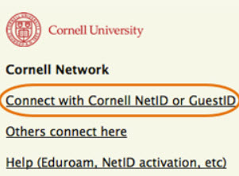
RedRover Wireless Connection for Guests
- Click on Network icon.
- Select RedRover.
- Click Connect.
- Follow the instructions provided.

Instructions can be found at:
http://www.it.cornell.edu/servics/wifi/howto.cfm

Lecture Room Projection – Windows

Connection Summary
*These instructions are for laptops and devices using Windows 7. If you are using Windows 8 some steps may be slightly different.

To use the AV System in this room, you will use the white Control Panel on the lectern labeled Crestron.

There are 5 steps to setting up the Room Projection:

- Connect your device
- Audio setup
- Annotation setup
- Change display
- Recording setup

Input Source Choices

Lectern 1: Devices plugged into the podium on the left.
Lectern 2: Devices plugged into the podium on the right.
AirMedia: Allows sharing of mobile content wirelessly.

Connect Your Device
- If there is no display on the black Crestron, touch the screen to wake it up.
- Press the screen again to enter the system.
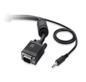
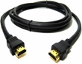
- Plug either the VGA & Audio cables (use the headset jack) or the HDMI cable into your computer. These cables are located at the table box labeled Lectern 1.
VGA & Audio
HDMI

If no projection: Remove the VGA or HDMI cable from your computer and reconnect the appropriate cable to check the connection to your computer or see FAQ’s.

Audio Setup (Optional)
- Plug the Audio Input cable into the headset jack on your device.
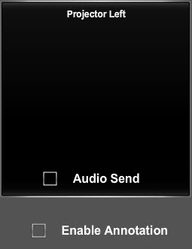
- Check Audio Send in appropriate Projector box.

If using HDMI:
- Go to Control Panel.
- Click on Sound.
- Click on Playback Tab.
- Choose Crestron as the Default.

Annotation Setup (Optional)
Smart software and Smart Drives are required to use this device.
- Plug the USB cable labeled Annotator & AV Bridge located at the table box labeled Lectern 1 into your computer.
- Check Enable Annotation in the Projector left box.
- Turn the Smart Monitor power on.
- Verify that your content is projected on the Smart Monitor.

For more details see Smart Annotation Instructions on page 39.

Change Display (Optional)
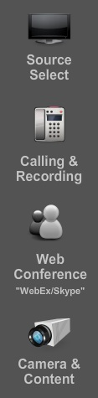
- Press Source Select on the Crestron Screen, if it is not already on the Home screen.
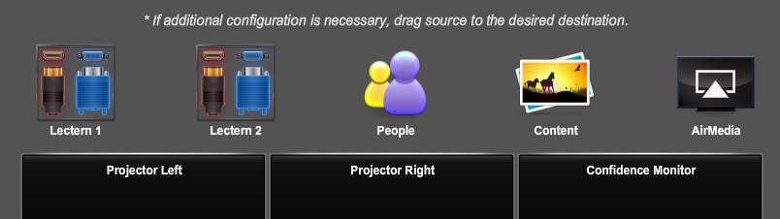
- Press and hold the source item on the top of the Crestron Screen (e.g. People, Content, etc.) and drag it into the appropriate box: Projector Left, Projector Right or Confidence Monitor.
Home Screen

Recording Setup (Optional)
- Press Call & Recording on the Crestron screen.
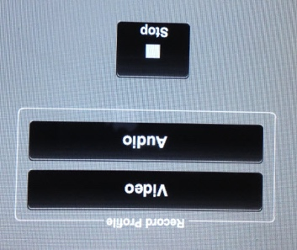
- Press Recording on the lower right side of the Crestron screen.
- Press the option in Record Profile that you would like to record.
- When finished recording press Stop.
- To retrieve your recording, contact: itcoescis-help@cornell.edu.

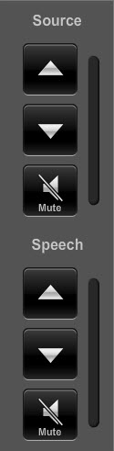
Volume, Mute and Unmute

By pressing the Vol Up, Vol Down buttons you can change the Speech (Microphone) and Source (Room Speaker) volume.
By pressing the Mute button, you can mute the Speech (Microphone) and/or Source (Room Speaker).
Mute is on when the Mute button is highlighted in Red.

Shut Down and Restart

- Shutdown the system by touching the power icon in the bottom left of the Crestron Screen.

You will have 15 seconds to press Return to System to cancel the shut down.

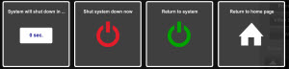
If you do not press Return to System, a countdown clock will appear signaling the beginning of a 200 second cool down period.

Web-Based Video Conferencing – Windows

Connection Summary
*These instructions are for laptops and devices using Windows 7. If you are using Windows 8 some steps may be slightly different.

To use the AV System in this room, you will use the white Control Panel on the lectern labeled Crestron.

There are 3 steps to setting up Web-Based Video Conferencing:

- Connect your device
- Input for projection
- Start conference

Web Conferencing Software
Please note: If you are hosting a conference session, you must install your preferred conferencing software (either WebEx or Skype) on your laptop and, if necessary, obtain a campus account. Google Plus does not require software installation.

For WebEx instructions see: http://www.it.cornell.edu/services/webconferencing/

Connect Your Device
- Plug the USB cable labeled Annotator & AV Bridge, located at the table box labeled Lectern 1, into your computer.
- Follow the instructions for Lecture Room Projection for Windows, on page 6, steps 1 and 2.

Input for Projection
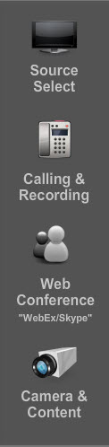
- Press Source Select on the Crestron.
- The recommended source setup configuration for Video Conferencing is: People in Confidence Monitor, People in Projector Left, and Content in Projector Right.
- Press and hold the source item on the top of the Crestron screen and drag it into the appropriate box: Projector Left, Projector Right, or Confidence Monitor.
Home Screen

Start Conference on Your Device

Choose Google Plus, WebEx, or Skype

Google Plus (Hangouts)

- Begin or join a Google Hangout Video Call.
- Click on the round Gear “Settings” icon on the top of the Google Video call page.
- Select UVC from the Camera drop down menu to use the room camera.
- Click Save.
- Select Independent (R.T.C.) Headphones (IDT High Definition Audio codec) from the Speaker drop down menu.
- Select Microphone 2-AV Bridge for the Microphone.
- Click Save

Start Conference on Your Device Cont.

WebEx

The local call-in number for the Crestron is: (607) 255-4446.

- Start a meeting in WebEx.
- Click on the round Gear “Video Setting” on the upper right side of the screen.
- Select UVC from the Camera drop down menu to use the room camera.
- Click on Audio in the menu bar at the top of the screen.
- Click on Speaker/Microphone Audio test.
- Select Independent (R.T.C.) Headphones (IDT High Definition Audio codec).
- Select Microphone 2-AV Bridge for the Microphone.
- Click OK.

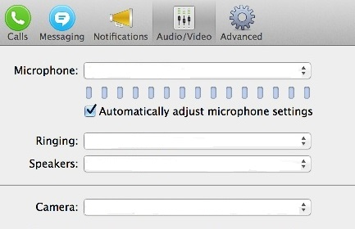
Skype
- Start a Skype call.
- Click on Skype in the top left corner of the screen.
- Click Preferences.
- Click the Audio/Video tab.
- Select UVC from the Camera drop down menu to use the room camera.
- Choose Independent (R.T.C.) Headphones (IDT High Definition Audio codec) for the Speakers.
- Choose Microphone 2-AV Bridge for the Microphone.

WebEx with PowerPoint – Windows

Connection Summary
*These instructions are for laptops and devices using Windows 7. If you are using Windows 8 some steps may be slightly different.

To use the AV System in this room, you will use the white Control Panel on the lectern labeled Crestron.

There are 4 steps to setting up WebEx with PowerPoint:

- Connect your device
- Input for projection
- Start conference
- Send content full screen

Web Conferencing Software
Please note: If you are hosting a conference session, you must install WebEx on your device and if necessary, obtain a campus account.

For WebEx instructions see: http://www.it.cornell.edu/services/webconferencing/

Connect Your Device
- Plug the USB cable labeled Annotator & AV Bridge located at the table box labeled Lectern 1, into your computer.
- Follow the instructions for Lecture Room Projection for Windows, on page 6, steps 1 and 2.

Input for Projection
- Press Source Select on the Crestron.
- The recommended source setup for Video Conferencing is People in Confidence Monitor, People in Projector Left, and Content in Projector Right.
- Press and hold the source item on the top of Crestron screen and drag it into the appropriate box: Projector Left, Projector Right, or Confidence Monitor.
Home Screen

Start Conference on Your Device

WebEx

The local call-in number for the Crestron is: (607) 255-4446.

- Start a meeting in WebEx.
- Click on the round Gear “Video Setting” on the upper right side of the screen.
- Select UVC from the Camera drop down menu to use the room camera.
- Click on Audio in the menu bar at the top of the screen.
- Click on Speaker/Microphone Audio test.
- Select Independent (R.T.C.) Headphones (IDT High Definition Audio codec).
- Select Microphone 2-AV Bridge for the Microphone.
- Click OK.

Send Content Full Screen
- Start your slide show.
- Press and hold Alt + Tab.
- When WebEx appears on the screen, left click on it.
- In WebEx, click the down arrow next to “Share My Desktop.”
- Select “Share My Desktop.”
- Your slide show is now being shared and you may begin your presentation.
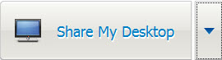

Lecture Room Projection – Mac

Connection Summary
*These instructions are for laptops using Mac OS 10.8 or newer. Earlier OS platforms may be slightly different.

To use the A/V in the room, you will use the white Control Panel on the lectern labeled Crestron.

There are 5 steps to setting up the Room Projection:

- Connect your device
- Audio setup
- Annotation setup
- Change display
- Recording setup

Input Source Choices
Lectern 1: Devices plugged into the podium on the left.
Lectern 2: Devices plugged into the podium on the right.
AirMedia: Allows sharing of mobile content wirelessly.

Connect Your Device
- If there is no display on the Crestron unit, tap the screen with your finger.
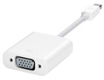
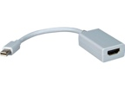
- Plug the VGA and Audio Input cables (use the headset jack) or the HDMI cable into your computer. These cables are located at the table box labeled Lectern 1.
HDMI
VGA & Audio
Adapter
Adapter
- Click on the Apple in the upper left corner of your computer.
- Click on System Preferences.
- Click on Display.
- Click on Arrangement.
- Click on Mirror Display.
- Verify that your image is being projected on the room screens.
- If no projection: remove the VGA or HDMI cable from your computer and reconnect the appropriate cable to check the connection to your computer or see FAQs.

Audio Setup (Optional)
- Plug the Audio Input cable into the headset jack on your device.
- Check Audio Send in appropriate Projector box.

If no sound:
- Click on the Apple in the upper left corner of your computer.
- Click on System Preferences.
- Click on Sound.
- Choose Crestron if using HDMI.
- Choose AV Bridge if using VGA.

Annotation Setup (Optional)
Smart software and Smart Drives are required to use this device.
- Plug the USB cable labeled Annotator & AV Bridge located at the table box labeled Lectern 1 into your computer.
- Check Enable Annotation in the Projector Left box.
- Turn the Smart Monitor power on.
- Verify that your content is projected on the Smart Monitor.

For more Details see Smart Annotation Instructions on page 39.

Change Display (Optional)
- Press Source Select on the Crestron Screen, if it is not already on the Home screen.
- Press and hold the source item on the top of the Crestron Screen (e.g. People, Content, etc.) and drag it into the appropriate box: Projector Left, Projector Right or Confidence Monitor.
Home Screen

Recording Setup (Optional)
- Press Call & Recording on the Crestron screen.
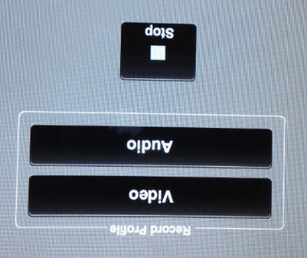
- Press Recording on the lower right side of the Crestron screen.
- Press the option in Record Profile that you would like to record.
- When finished recording press Stop.
- To retrieve your recording, contact: itcoescis-help@cornell.edu.

Volume, Mute and Unmute

By pressing the Vol Up, Vol Down buttons you can change the Speech (Microphone) and Source (Room Speaker) volume.
By pressing the Mute button, you can mute the Speech (Microphone) and/or Source (Room Speaker).

Mute is on when the Mute button is highlighted in Red.

Shut Down and Restart

Shutdown the system by touching the power icon in the bottom left of the Crestron Screen.

You will have 15 seconds to press Return to System to cancel the shut down.
If you do not press Return to System, a countdown clock will appear signaling the beginning of a 200 second cool down period.

Web-Based Video Conferencing – Mac

Connection Summary
*These instructions are for laptops using Mac OS 10.8 or newer. Earlier OS platforms may be slightly different.

To use the A/V in the room, you will use the white Control Panel on the lectern labeled Crestron.

There are 3 steps to setting up Web-Based Video Conferencing:

- Connect your device
- Input for projection
- Start conference

Web Conferencing Software
Please note: If you are hosting a conference session, you must install your preferred conferencing software (either WebEx or Skype) on your laptop and, if necessary, obtain a campus account. Google Plus does not require software installation.

For WebEx instructions see: http://www.it.cornell.edu/services/webconferencing/

HDCP Notice
The AV system supports authorized playback of HDCP protected content. As a form of copy protection, HDCP encoded content *will not* be able to be displayed at the remote video conference site, regardless of fair use status. Because Apple tags all content output as HDCP enabled, output from Apple devices (including PowerPoints and other content) may not be displayed at the remote site during a video conference.

Connect Your Device
- Plug the USB cable labeled Annotator & AV Bridge, located at the table box labeled Lectern 1, into your computer.
- Follow the instructions for Lecture Room Projection for Mac, on page 15, steps 1 and 2.

Input for Projection
1. Press Source Select on the Crestron.
2. The recommended source setup configuration for Video Conferencing is: People in Confidence Monitor, People in Projector Left, and Content in Projector Right.
3. Press and hold the source item on the top of the Crestron screen and drag it into the appropriate box: Projector Left, Projector Right, or Confidence Monitor.
Home Screen

Start Conference on Your Device

Choose Google Plus, WebEx, or Skype

Google Plus (Hangouts)

- Join a Google Hangout Video Call.
- Click on the round Gear “Settings” icon on the top of the Google Video call page.
- Select AV Bridge from the Camera drop down menu to use the room camera.
- Click Save.
- Select Crestron from the Default Speaker drop down menu.
- Click Save.

Start Conference on Your Device Cont.

WebEx

The local call-in number for the Crestron is: (607) 255-4446.

- Start a meeting in WebEx.
- Click on the round Gear “Video Setting” on the lower right side of the screen.
- Select AV Bridge from the Camera drop down menu to use the room camera.
- Click on Audio in the menu bar at the top of the screen.
- Click on Speaker/Microphone Audio test.
- Select HDMI-Crestron in the speaker drop down.
- Select AV Bridge in the Microphone drop down.
- Click OK.

Skype

- Start a Skype call.
- Click on Skype in the top left corner of the screen.
- Click Preferences.
- Click the Audio/Video tab.
- Select AV Bridge from the Camera drop down menu to use the room camera.
- Choose HDMI-Crestron for the Speakers.
- Choose AV Bridge for the Microphone.

WebEx with PowerPoint – Mac

Connection Summary
*These instructions are for laptops using Mac OS 10.8 or newer. Earlier OS platforms may be slightly different.

To use the A/V in the room, you will use the white Control Panel on the lectern labeled Crestron.

There are 4 steps to setting up WebEx with PowerPoint:

- Connect your device
- Input for projection
- Start conference
- Send content full screen

Web Conferencing Software
Please note: If you are hosting a conference session, you must install WebEx on your device and, if necessary, obtain a campus account.

For WebEx instructions see: http://www.it.cornell.edu/services/webconferencing/

Connect Your Device
- Plug the USB cable labeled Annotator & AV Bridge, located at the table box labeled Lectern 1, into your computer.
- Follow the instructions for Lecture Room Projection for Mac, on page 15, steps 1 and 2.

Input for Projection
- Press Source Select on the Crestron.
- The recommended source setup configuration for Video Conferencing is: People in Confidence Monitor, People in Projector Left, and Content in Projector Right.
- Press and hold the source item on the top of the Crestron screen and drag it into the appropriate box: Projector Left, Projector Right, or Confidence Monitor.
Home Screen

Start Conference on Your Device

WebEx

The local call-in number for the Crestron is: (607) 255-4446.
- Start a meeting in WebEx.
- Click on the round Gear “Video Setting” icon on the lower right side of the screen.
- Select AV Bridge from the Camera drop down menu to use the room camera.
- Click on Audio in the menu bar at the top of the screen.
- Click on Speaker/Microphone Audio test.
- Select HDMI-Crestron in the speaker drop down.
- Select AV Bridge in the Microphone drop down.
- Click OK.

Send Content Full Screen
- Click on the Apple at the top of your screen.
- Click on System Preferences.
- Click on the Display icon.
- Click the Arrangement tab.
- Click and hold on the white bar at the top of the current primary display.
- Drag the white bar across to the other monitor you want to set as the primary display for your Mac.
- Close out of this screen.
- Start your PowerPoint slide show.
- Press and hold Command + Tab to switch to WebEx.
- Click the arrow next to “Share My Desktop.”
- Select “Microsoft PowerPoint.”

Please note: HDCP Notice

The AV system supports authorized playback of HDCP protected content. As a form of copy protection, HDCP encoded content *will not* be able to be displayed at the remote video conference site, regardless of fair use status. Because Apple tags all content output as HDCP enabled, output from Apple devices (including PowerPoints and other content) may not be displayed at the remote site during a video conference.

AirMedia Stand Alone – Wireless Connection

Connection Summary
To use the Stand Alone AirMedia in the room, you will use the white Control Panel on the lectern labeled Crestron.

There are 4 steps to setting up AirMedia:

- Lower room screens
- Download the app/software
- Project IP address and code
- Connect to AirMedia

AirMedia allows participants to connect to the Room AV System wirelessly and project content from their device.

AirMedia with the AV System (Optional)
You may also use AirMedia by connecting to the room AV system. You can find these instructions at:
AirMedia for iOS Devices pg. 26
AirMedia for Android Devices pg. 29
AirMedia for Laptops pg. 32

Lower Room Screens
- Locate the screen controls on the wall by the main door, labeled Screen Controls.
- Press the down arrows to lower the screen.

Download the App/Software
- Make sure the device you are connecting to AirMedia is connected to Wi-Fi.
- Download the free AirMedia App/Software for the selected device at:
http://www.crestron.com/products/airmedia_mobile_wireless_hd_presentations/#connect

(For instructions on connecting to wireless internet, see the Internet Connection Options on page 5.)

Project IP Address and Code
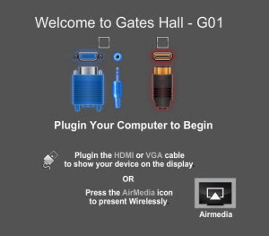
- If there is no display on the Crestron screen, tap the screen with your finger.
- Press AirMedia on the Crestron screen.
- By default, AirMedia will be displayed on the Left Projector.
- AirMedia may take a minute or two before it is projected on the room screen.
- Verify the IP Address and the Code are projected on the room screen.

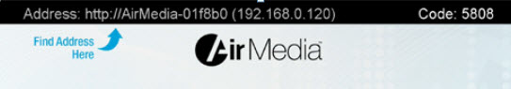

Connect to AirMedia
- Start the AirMedia App/Software on the chosen device.
- Locate the instructions for your device and proceed with Step #4 on the instructions: Connect to AirMedia.
AirMedia for iOS Devices pg. 26
AirMedia for Android Devices pg. 29
AirMedia for Laptops pg. 32

AirMedia for iOS – Wireless Connection

Connection Summary
To use the AV System in the room, you will use the white Control Panel on the lectern labeled Crestron.

There are 5 steps to setting up AirMedia:

- Connect your device
- Download the app
- Project AirMedia
- Connect to AirMedia
- Choose content to project

AirMedia allows participants to connect to the Room AV System wirelessly and project content from their device.

Stand Alone AirMedia (Optional)
AirMedia can also be used without connecting to the room AV system. The Stand Alone AirMedia instructions can be found on page 24.

Connect Your Device
- Follow the instructions for Lecture Room Projection. Choose the instructions for Windows on page 6 or Mac on page 15, steps 1 and 2, depending on the device you are connecting to the room’s AV System.

Download the App
- Make sure the device you are connecting to AirMedia is connected to Wi-Fi.
- Download the free AirMedia App for the selected device at:
http://www.crestron.com/products/airmedia_mobile_wireless_hd_presentations/#connect
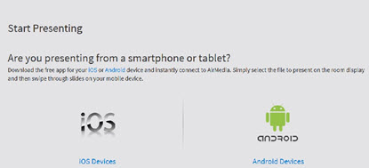

(For instructions on connecting to wireless internet, see the Internet Connection Options on page 5.)

Project AirMedia
- Choose Source Select on the Crestron, if the home screen is not already displayed.
- Press AirMedia on the Crestron screen either on Projector Left, Projector Right, or Confidence Monitor, depending on where you want the content to be projected.
- Verify that AirMedia is projected on the room screen.
- By default both the IP Address and Code are shown at the top of the room screen.

Connect to AirMedia

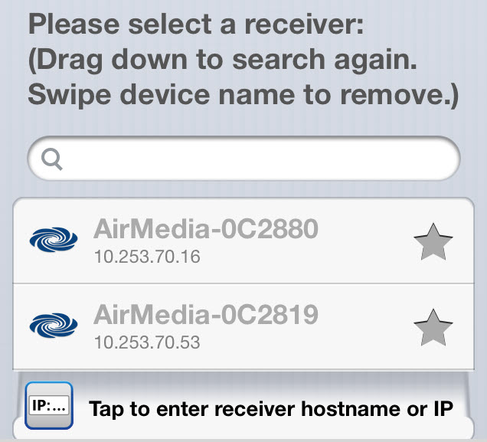
- Start the app on the chosen device.
- If the IP address appears on the device, verify it is the same as projected on the room screen.
- Choose the correct IP address on your device.
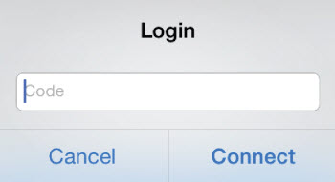
- Enter the AirMedia Code that is projected on the room screen.

Choose Content to Project

- Choose the content to project from the chosen device.
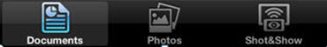

AirMedia for Android – Wireless Connection

Connection Summary
To use the AV System in the room, you will use the white Control Panel on the lectern labeled Crestron.

There are 5 steps to setting up AirMedia:

- Connect your device
- Download the app
- Project AirMedia
- Connect to AirMedia
- Choose content to project

AirMedia allows participants to connect to the Room AV System wirelessly and project content from their device.

Stand Alone AirMedia (Optional)
AirMedia can also be used without connecting to the room AV system. The Stand Alone AirMedia instructions can be found on page 24.

Connect Your Device
- Follow the instructions for Lecture Room Projection. Choose the instructions for Windows on page 6 or Mac on page 15, steps 1 and 2, depending on the device you are connecting to the room’s AV System.

Download the App
- Make sure the device you are connecting to AirMedia is connected to Wi-Fi.
- Download the free AirMedia App for the selected device at:
http://www.crestron.com/products/airmedia_mobile_wireless_hd_presentations/#connect

(For instructions on connecting to wireless internet, see the Internet Connection Options on page 5.)

Project AirMedia
- Choose Source Select on the Crestron, if the home screen is not already displayed.
- Press AirMedia on the Crestron screen either on Projector Left, Projector Right, or Confidence Monitor, depending on where you want the content to be projected.
- Verify that AirMedia is projected on the room screen.
- By default both the IP Address and Code are shown at the top of the room screen.

Connect to AirMedia

- Start the app on the chosen device.
- If the IP address appears on the device, verify it is the same as projected on the room screen.
- Choose the correct IP address on your device.
- Enter the AirMedia Code that is projected on the room screen.

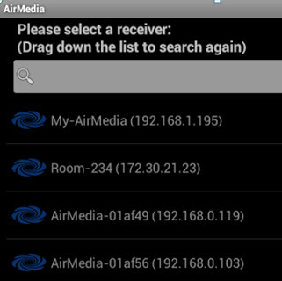

Choose Content to Project

- Choose the content to project from the chosen device.

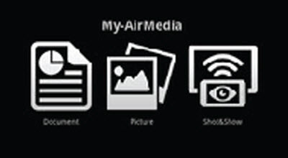

AirMedia for Laptops – Wireless Connection

Connection Summary
To use the AV System in the room, you will use the white Control Panel on the lectern labeled Crestron.

There are 5 steps to setting up AirMedia:

- Connect your laptop
- Download the software
- Project AirMedia
- Connect to AirMedia
- Choose content to project

AirMedia allows participants to connect to the Room AV System wirelessly and project content from their laptop.

Stand Alone AirMedia (Optional)
AirMedia can also be used without connecting to the room AV system. The Stand Alone AirMedia instructions can be found on page 24.

Connect Your Device
- Follow the instructions for Lecture Room Projection. Choose the instructions for Windows on page 6 or Mac on page 15, steps 1 and 2, depending on the device you are connecting to the room’s AV System.

Download the Software
- Make sure the device you are connecting to AirMedia is connected to Wi-Fi.
- Download the free AirMedia Software for the selected device at:
http://www.crestron.com/products/airmedia_mobile_wireless_hd_presentations/#connect
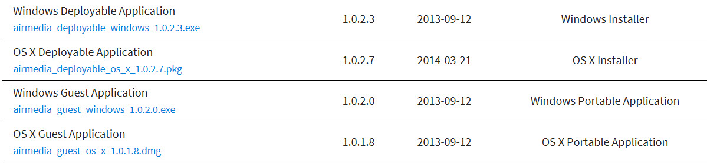

(For instructions on connecting to wireless internet, see the Internet Connection Options on page 5.)

Project AirMedia
- Choose Source Select on the Crestron, if the home screen is not already displayed.
- Press AirMedia on the Crestron screen either on Projector Left, Projector Right, or Confidence Monitor, depending on where you want the content to be projected.
- Verify that AirMedia is projected on the room screen.
- By default both the IP Address and Code are shown at the top of the room screen.

Connect to AirMedia

- Start the software on your laptop.
- Follow the instructions on the laptop screen.
- Enter the IP Address and Code that is projected on the room screen.

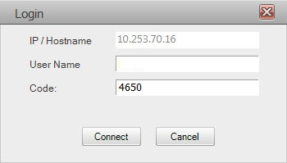

Choose Content to Project

- Choose the content to project from the laptop.

AirMedia with a computer is mirroring the image of your computer wirelessly.

Video Conferencing

Connection Summary
To use the AV System in the room, you will use the white Control Panel on the lectern labeled Crestron.

There are 5 steps to setting up Video Conferencing:

- Connect your device
- Input for displays
- Content for remote site
- Select camera
- Place the call

Input Source Choices

Laptop 1: Device plugged into the podium on the left.
Laptop 2: Device plugged into the podium on the right.
AirMedia: To allow people to share laptop or mobile content wirelessly.

Connect Your Device

- Plug the USB cable labeled Annotator & AV Bridge, located at the table box labeled Lectern 1, into your computer.
- Follow the instructions for Lecture Room Projection. Choose the instructions for Windows on page 6 or Mac on page 15, steps 1 and 2, depending on the device you are connecting to the room AV system.

Input for Displays
1. Press Source Select on the Crestron.
2. The recommended source setup configuration for Video Conferencing is: People in Confidence Monitor, People in Projector Left, and Content in Projector Right.
3. Press and hold the source item on the top of the Crestron screen and drag it into the appropriate box: Projector Left, Projector Right, or Confidence Monitor.
Home Screen

Content for Remote Site
- Press Camera and Content on the Crestron.
- Press Content on the bottom right.
- Press Lectern 1, Lectern 2, AirMedia, or No Content to send to the remote site.
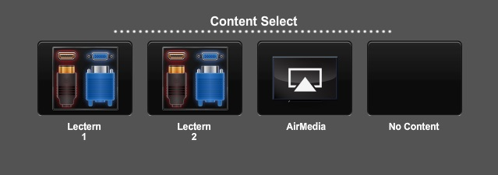

Select Camera
- Press Camera & Content on the Crestron.
- Press either Student or Instructor/Presenter camera to send to the remote site.
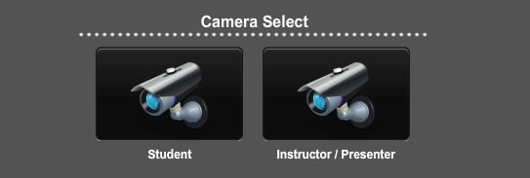

Place the Call
- Press Calling and Recording on the Crestron.
- Choose either the IP address of the bridge/remote system, the Address Book or the Dialer.
- Press Call/Answer on the Crestron.
- If you choose to enter an IP address, you need to include the periods (e.g. 10.1.1.1)
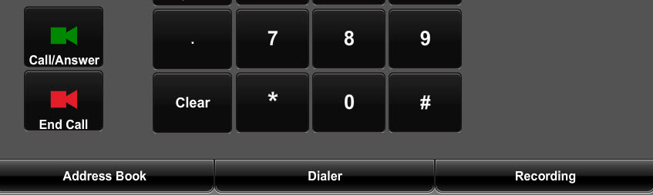
- If you choose to dial, touch the Dialer tab at the bottom of the Crestron screen and enter the number. Dialing “9” is necessary to obtain an outside line.

Mute/Unmute and Volume
…

Camera Control
- Press Camera & Content on the Crestron screen.
- Press Camera Control on the bottom of the Crestron screen.
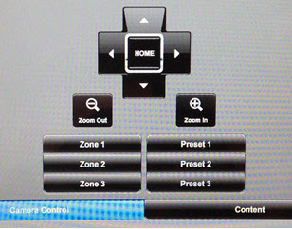
- As desired, touch the controls for zoom, pan, or directional.

Smart Annotation

Connection Summary
To use the AV System in the room, you will use the white Control Panel on the lectern labeled Crestron.

There are 5 steps to setting up Smart Annotation:

- Connect your device
- Download software
- Enable annotation
- Install drivers
- Calibration

You must have the Smart software installed on your computer to use this device.

Support
Additional information about Smart Annotation can be found at:

http://knowledgebase.force.com/pk_Home?l=en_US&q=24%20hd

Connect Your Device
- Follow the instructions for Lecture Room Projection. Choose the instructions for Windows on page 6 or Mac on page 15, steps 1 and 2, depending on the device you are connecting to the room AV system.

Download Software
- Smart Podium software can be found at:
http://smarttech.com/Downloads
- Select “SMART Product Drivers.”

Enable Annotation
- If not already plugged in: Plug the USB cable labeled Annotator & AV Bridge, located at the table box labeled Lectern 1, into your device.
- Check Enable Annotation in the Projector Left box.
- Turn the Smart Monitor on.
- Verify your content is projected on the Smart Monitor.

Install Drivers
- Be sure the USB cable labeled Annotator & AV Bridge, located at the table box labeled Lectern 1, is connected to your device.
- The drivers will install automatically when the USB is plugged in.

Calibration
- Press on the Orient Button located in the frame above the Smart Podium screen, at the far right.
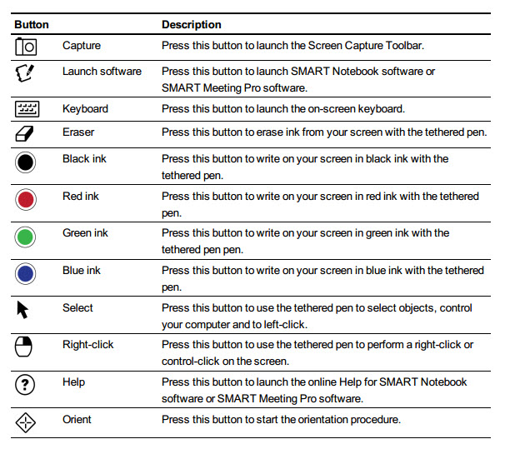
- Follow the on-screen instructions using the Smart Podium Pen.

FAQs

Crestron
Q. What if the Crestron Screen goes to shut down mode after I plug in the VGA or the HDMI cable?
A. Press the green Return to System button on the Crestron screen.
Q. The room’s screens do not come down when I plug the VGA or HDMI cable into my computer.
A. Use the wall mounted screen controls to put the screens down.
Q. No projected image appears on the room screen.
- Make sure the appropriate Source item on the Crestron Screen is selected in the desired projection box.
- Check that the VGA or the HDMI cable is securely plugged in to your computer.
- Press the Power off button to restart the Crestron.

No Audio
Q. The room speakers are not working.
- Make sure the Audio Cable is plugged into your computer’s headphone jack.
- Make sure that Enable Audio is checked on the Crestron Screen in the appropriate window.
- Check the Audio settings on your computer.

No Annotation
Q. The Annotation device is not working.
- Check that the USB cable labeled Annotator & AV Bridge is securely plugged in to your computer.
- Make sure the Enable Annotation is checked on the Crestron Screen in the appropriate window.
- Make sure the Smart Software was installed on your computer. Smart Podium software can be found at:
http://smarttech.com/Home+Page/Support/Browse+Support/Download+Software

Welcome to Gates 114
Projection Quick Tips

To manually lower or raise the raise screen use the buttons labeled “Screen Controls,” located on the wall by the door closest to the screens.
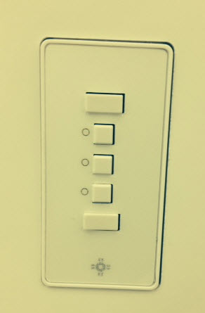
To adjust the blinds in the room use the controls on the wall by the lighting controls.

Crestron Controls

By pressing the Up Arrow and Down Arrow buttons you can change the Speech (Microphone) and Source (Speaker) volume.

By pressing the Mute button, you can mute the Speech (Microphone) and Source (Speaker).

Mute is on when the mute button is highlighted in red.

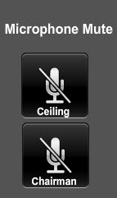
In the Calling and Recording screen on the Crestron, you can mute the Ceiling or Chairman Microphone by pressing until highlighted.

If the Crestron goes into Shut Down Mode before your session is over, press Return to System.
Be sure to shut down the Crestron after your session.

AirMedia does not automatically turn off. Be sure to close AirMedia on your device before leaving the room.

Be sure you have pressed Stop on the Crestron if you are recording from the Crestron. The Recording function does not automatically turn off.

