Contact Information:
For AV support:
In Case of an AV Emergency Call: 607-255-0778
Email: Eng. Classtech Support itcoecis-help@cornell.edu
AV Support Availability: Monday thru Friday, 8:00am to 5:30pm

For Facilities assistance:
Submit a ticket: https://tdx.cornell.edu/TDClient/133/Portal/Home/

For Emergencies Dial: 911 CU Police: 607-255-1111

Room Equipment:
Projector Projection Screen Speakers
Microphones Lecture Capture Videoconferencing
Wireless Presentation Web Conferencing

For a list of available optional equipment please contact Kathy Dimiduk (klc78@cornell.edu)

Basic Presentation
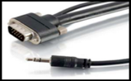
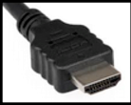
HDMI 1 & 2 VGA Wireless Presentation
(Digital) (Analog) (AirMedia)
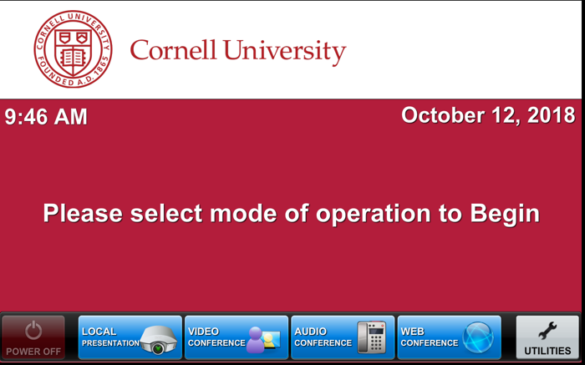

Note: If you connect your device through a source above while the Crestron is on the home page, the far projector screen will automatically lower and your presentation will automatically appear on both the far projector screen and distance learning screen located in the back of the room.

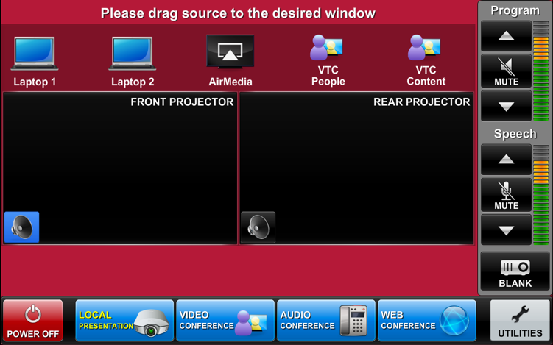
- Drag your source into the display area you wish to project on (front or rear). Note that the projectors have independent images. You can select a different source for each projector by dragging it to the display area as show by the bottom right picture.
*(To view all sources that are available, simply swipe right and left at the top row of sources.)*
- Once finished dragging, the screen(s) will automatically lower and your presentation will appear on the projector screen(s). If they do not automatically lower, there is a manual control for the screens located near the door.

- To shut down the system, press Power Off on the lower left side of the Crestron screen. The document camera must be turned off manually.

Audio
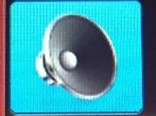
Sound will be projected from the most recent source selected and the speaker by that source will turn blue.

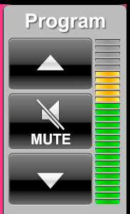
If necessary, select the sound from your other source by touching the
speaker icon by the source.

To adjust the room speaker volume, use the up and down Program arrows located on the right side of the Crestron.

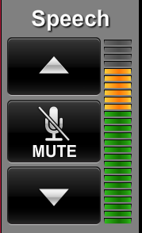
The microphone is in the top drawer of the cabinet attached to
the podium. Turn on the unit and adjust the microphone volume
using the up and down Speech arrows also located on the right side of the Crestron. New batteries are located in the same top drawer if needed.

Wireless Presentation
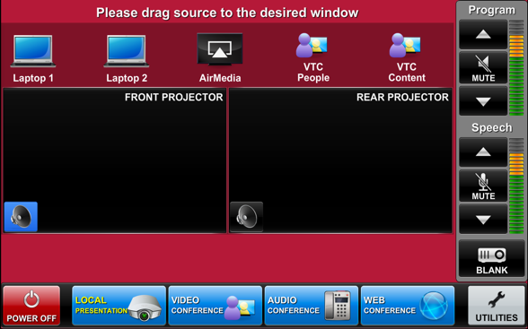
- Drag AirMedia to the Projector box
- Navigate to the IP Address on the screen (10.253.70.53).
- Download the appropriate version based on the computer you have (PC or Mac).
- When it downloads -> open the program
- If you get a warning message just hit okay. Re-enter the IP Address, your username, and the login code displayed on screen.
- After you’re connected to the AirMedia your laptop will display on screen. To stop displaying your laptop or pause the display, hit the pause or stop button.
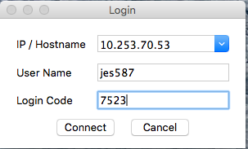
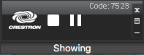

Zoom: Full-Featured Online Web and Video Conferencing Service

Note: To use Zoom make sure that you have downloaded the software and activated your Zoom account. Make sure you test the Zoom system in your classroom before using in class. Steps 1 through 7 show how to join a Zoom meeting. Skip to step 8 for setting up a Zoom meeting. This room is only capable of joining a Zoom meeting, it does not have the capability to create a Zoom meeting. Also note if you are teaching remotely using Zoom, you will need a person on campus, in this classroom, to open the Zoom meeting. If you have any questions regarding hosting a Zoom meeting, please visit: (https://support.zoom.us/hc/en-us/articles/201362613-How-Do-I-Host-A-Video-Meeting-)

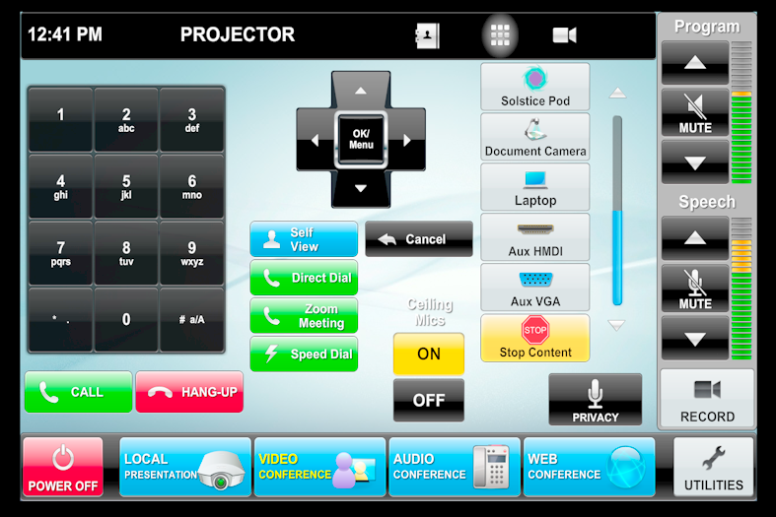
Joining a Zoom Meeting

- Tap the touch panel to wake it up. From the home screen, select ‘Video Conference’.

- Joining; The easiest way to join a Zoom meeting is to select the green ‘Zoom Meeting’ button

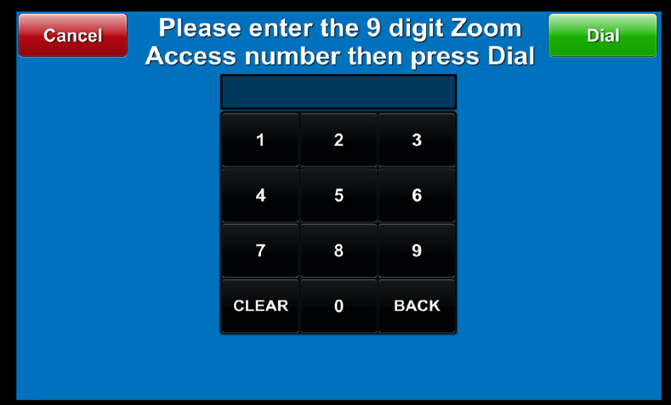
- Joining cont’d; This brings up the “Zoom Meeting Screen.” To join a Zoom meeting, just type in the Zoom meeting number and press the green “Dial” button in the upper right hand corner.

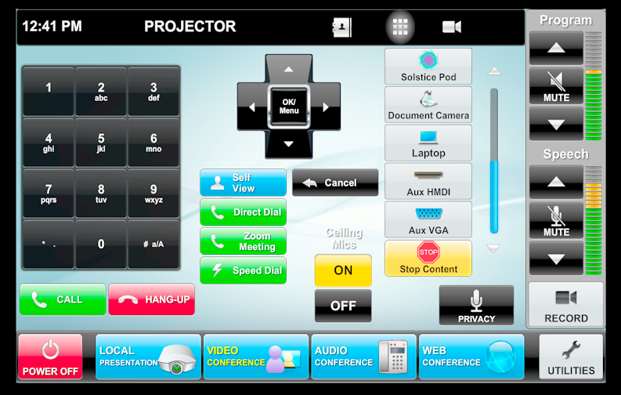
- Volume; The blue bar to the right of the gray buttons will determine the volume of the Zoom meeting. At the video conferencing controls, make sure that the “On” button under “Ceiling Mics” is yellow. If the local microphones aren’t working, try pressing the Privacy button once so it turns red, and then once more so it turns black again.

- Local Content; To share a laptop or other source from the classroom with the presenter, select it from the row of gray buttons on the right hand side of the screen.

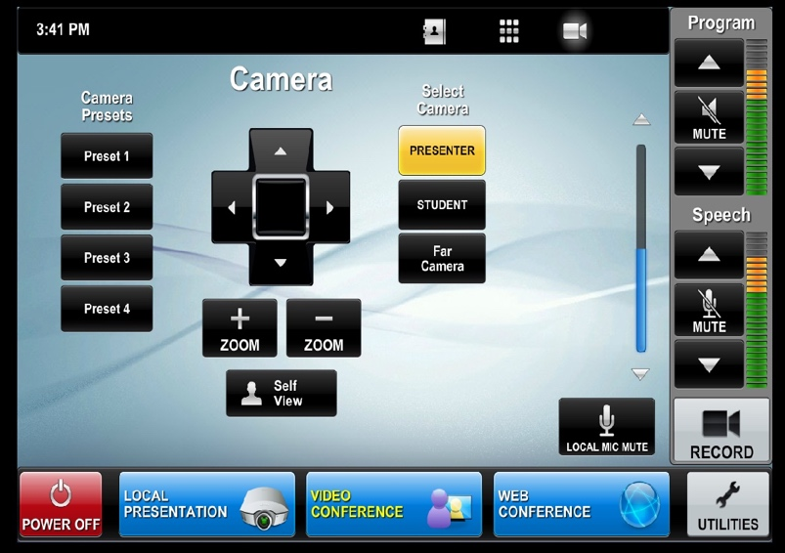
- Selecting Outgoing Camera; To change the outgoing camera view, touch the gray camera symbol on the right hand side of the black bar at the top of the screen.

- Camera Selection/Adjustments; You can select a camera (Sometimes called “Presenter” and “Student,” or “North” and “South”). You can use the arrow keys to move the camera the left and right or up and down, and there are “Zoom in” / “Zoom out” buttons under
the arrow controls. You can press “Self View” to see or hide what the other participants of the Zoom meeting will see.
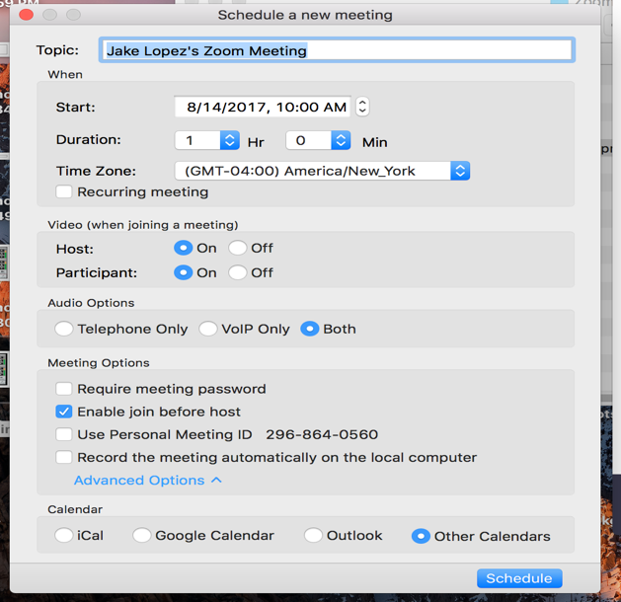
Scheduling a Zoom Meeting

- Scheduling Zoom Meeting; Make sure video for participant is on. When scheduling a Zoom Meeting for use with a room, you will want to click on ‘Advanced Options’ so you can see “Enable Join Before Host.” This will allow the room system to start the meeting if they join before anyone with a laptop does. Each user account can only have one active meeting at a time. (Zoom meeting must come from your
Device. You cannot set up a Zoom meeting
from the touch panel. )

Video Conferencing to Rooms with Video Conferencing Hardware

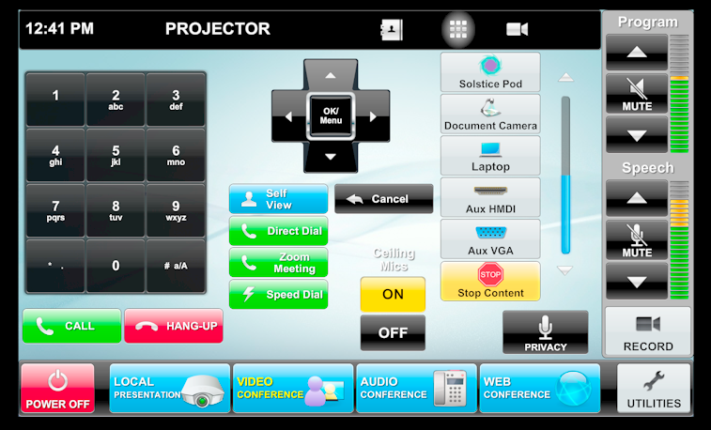
Note: Please make sure to test the room you’re trying to connect to before intended use.
- Tap the touch panel to wake it up.
From the home screen, select ‘Video Conference’.

- Contacts; From the Video Conferencing Screen, you can select the gray address book icon from the black bar at the top of the screen.

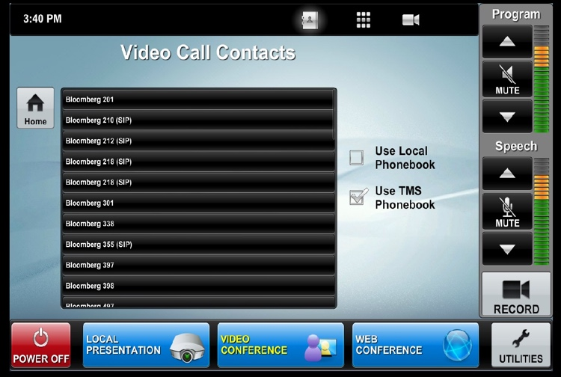
- Contacts Cont’d; This will bring up the directory of preconfigured locations. If you are calling a room in Ithaca, select “Use TMS Phonebook” to bring up a list of rooms. (Bloomberg Rooms only show in the TMS phone book)

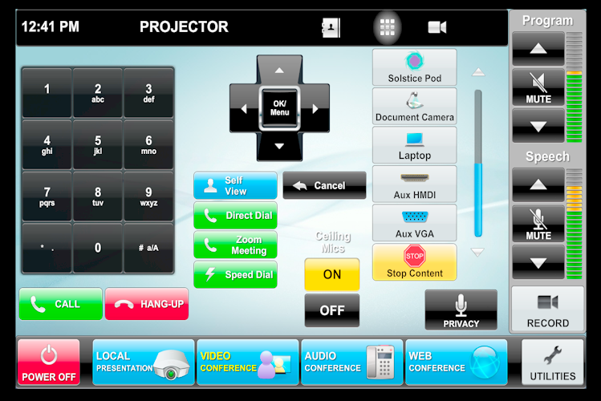
- Direct Call; You can also make a direct call by selecting the green “Direct Dial” button. *Note that if the room you’re trying to connect to is not in the directory, make sure that room has codec hardware otherwise you will not be able to connect to that room.

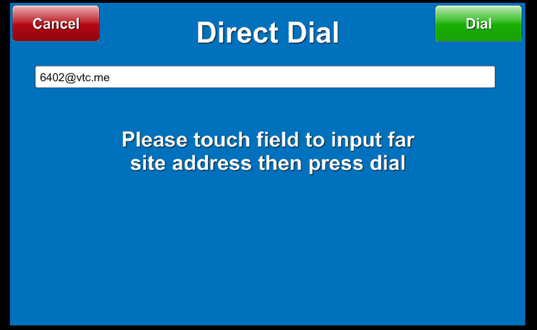
- Direct Call Cont’d; When direct dial is selected, you can enter a specific SIP address (ex: Phillips233@coecis.cornell.edu or Gates122@video.cornell.edu). You can also join a Zoom meeting by entering the Zoom meeting number followed by “@zoomcrc.com . When you touch the white bar, an onscreen keyboard should come up for you to enter. Once finished entering your desired SIP address, click the green “Dial” button located on the right top corner.
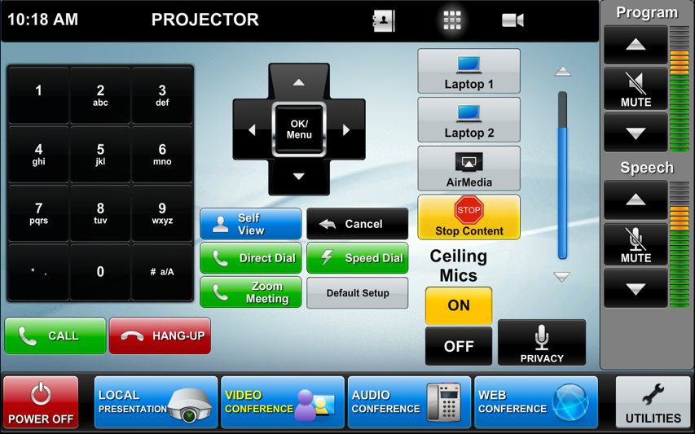
- Incoming Call; An incoming call
will cause a popup with a green
“Answer” button.

- Local Content; To share a screen or document camera, select it from the list of gray buttons on the right hand side of the screen. You will also want to make sure that the ceiling mics are set to “On”, and if there is no sound, try pressing the “Privacy” button once or twice to initialize the system.

Audio Conference
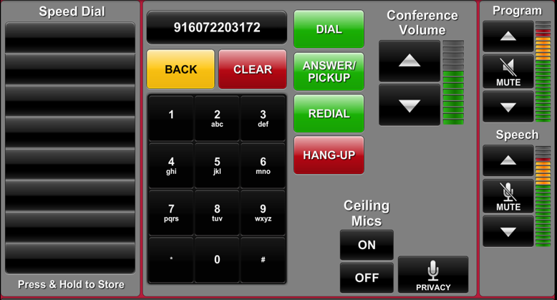
- Audio conference can be used to dial any phone number or conference line just like a regular phone.
- Dial 9-1 followed by the rest of the number and hit DIAL.
- Make sure the Ceiling Mics are on.
- The Audio Conference number is controlled by the Conference Volume bar.

Web Conference
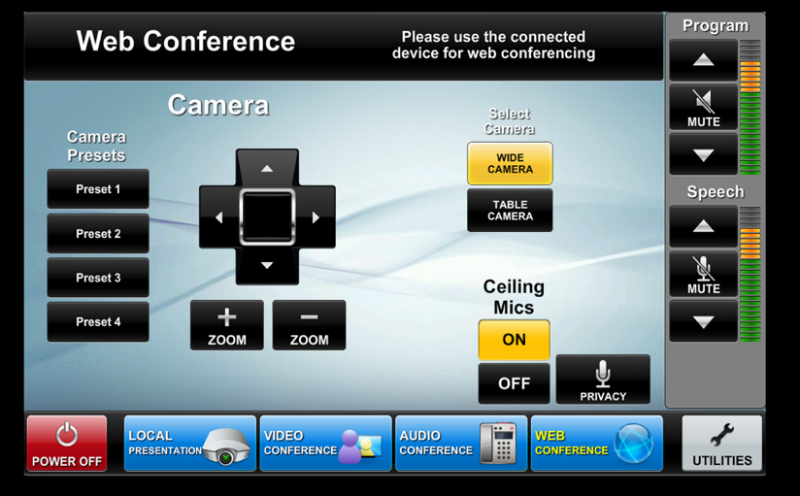
- Press the Web Conference button.
- From your laptop open Skype, Go To Meeting, Google Hangouts, act.
- Plug in the USB from the cable cubby on the table (this gives you access to the room cameras and ceiling mics).
- From this page displayed you can control the camera movements. As well as turning the ceiling mics on and off.

