Contact Information
For AV support:
In Case of an AV Emergency Call: 607-255-0778
Email: Eng. Classtech Support engrclasstech@cornell.edu
AV Support Availability: Monday thru Friday, 8:00am to 5:00pm

For Facilities assistance:
Submit a ticket: https://tdx.cornell.edu/TDClient/133/Portal/Home/

For Emergencies Dial: 911 CU Police: 607-255-1111

Room Equipment
2 Projector 2 Projector Screens Speakers
HDMI & USB-C Connections Assisted Listening

Connecting Your Device
- Connect your device
  - HDMI Connection
    - Choose the HDMI cable that matches the projector number (1 or 2). Turn on with the matching remote control.
  - Other Connections – using different adapters
    - Connect the HDMI cable directly into your required adapter then into your laptop.
    - Do not connect the HDMI adapter into another adapter, then into your laptop. This will compromise the display through the projector.
- Turn off the projector using the Power Button on the remote control in the room.

If your content is not fully projected on the screen:
Windows: | Mac:
- Press the “Windows” Key + P.  - Choose Duplicate. | - Click on the Apple at the top of your computer screen.  - Click on Preferences.  - Click on Display.  - Click on Arrangements.  - Click on Mirror Display.

Room Control
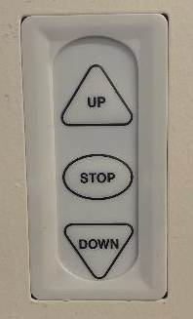
DO NOT PULL THE PROJECTOR SCREEN DOWN. Please use the projector screen switch located on the left of the projector screen, behind the lecturer’s podium, to raise or lower the projector screen.

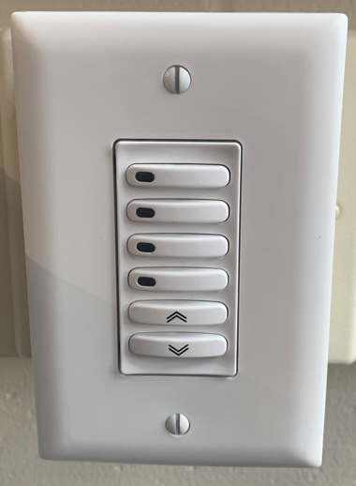
Light switches are located both in the back of the room next to the door and front of the room, next to the lecturer’s podium. Brightness level goes from 100%, 75%, 50%, 25% starting from the top button to the fourth button from the top. You can also turn up/down brightness level by toggling the up and down arrow buttons located at the bottom of the switch. Press the down arrow button once to turn off the lights. There is a delay of a couple of seconds so please be patient.

Please erase your white board and ask the students to erase theirs after use using the white sponge located in front of each white board.

Optional Equipment Available
For a list of available optional equipment, please visit:

https://www.engineering.cornell.edu/MTEI/mtei-equipment-check-out#no-back

