Contact Information
For AV support:
In Case of an AV Emergency Call: 607-255-0778
Email: Eng. Classtech Support engrclasstech@cornell.edu
AV Support Availability: Monday thru Friday, 8:00am to 5:00pm
For Facilities assistance:
Paul Charles pjc32@cornell.edu 607-351-6210

For Emergencies Dial: 911 CU Police: 607-255-1111

Room Equipment
Projector Projector Screen Speakers
Assisted Listening Wireless Presentation (AirMedia)

Room Control
- Connect your device
  - VGA Connection – Plug in the VGA cable into your computer.
  - HDMI Connection
    - Ensure that the VGA cable is connected to the VGA/HDMI adapter.
    - Plug the HDMI adapter cable into your laptop.
    - Plug in the power USB cable (attached to the adapter) into your laptop. Omitting this could cause your screen to flash and not display correctly.
  - Other Connections – using different adapters
    - Connect the VGA cable directly into your required adapter then into your laptop.
    - Do not connect the VGA/HDMI adapter into another adapter, then into your laptop. This will compromise the display through the projector.
  - Air Media Wireless Connection
    - Do not connect your laptop. The Air Media will display on the screen.
    - Navigate to the IP address on the top of the screen and download for either Mac or Windows.
    - Launch Air Media. It will search for a local device.
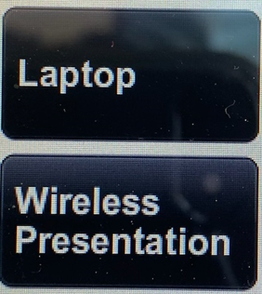
If it doesn’t recognize a device, follow the steps below:
      - Enter the IP Address on the top bar (eg. 10.22.35.19)
      - Your username should be your NetID
      - Enter the 4-digit code located on the top right of the Air Media screen.
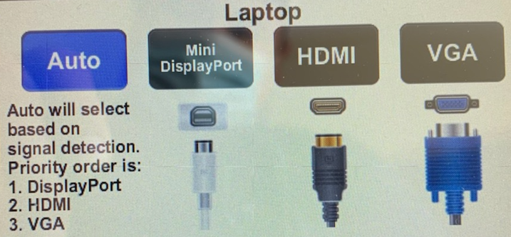
      - Press Connect.
- Turn on Projector from Touch Panel
  - If system does not start automatically, touch Manual Start. The projector screen will automatically come down.
  - Select desired connection (Laptop or Wireless Presentation). Make sure the correct source cable is connected.
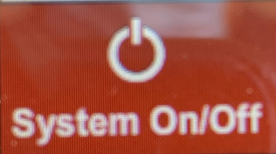
3. When finished, press the System On/Off button located at the bottom left of the Crestron. This will automatically shut down the projector and raise the projector screen.

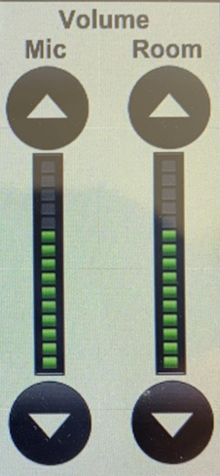
Audio
- Use the Room audio bar to adjust the audio level from the laptop connected.
- Use the Mute button under the Room audio bar to mute audio from the laptop connected.

If your content is not fully projected on the screen:
Windows: | Mac:
- Press the “Windows” Key + P.  - Choose Duplicate. | - Click on the Apple at the top of your computer screen.  - Click on Preferences.  - Click on Display.  - Click on Arrangements.  - Click on Mirror Display.

Optional Equipment Available
For a list of available optional equipment, please visit:

https://www.engineering.cornell.edu/MTEI/mtei-equipment-check-out#no-back

