Contact Information
For AV support:
In Case of an AV Emergency Call: 607-255-0778
Email: Eng. Classtech Support engrclasstech@cornell.edu
AV Support Availability: Monday thru Friday, 8:00am to 5:00pm

For Facilities support:
Submit a ticket: https://tdx.cornell.edu/TDClient/133/Portal/Home/
For Emergencies Dial: 911 CU Police: 607-255-1111

Room Equipment
1 Projector 1 Projector Screen Speakers
Assisted Listening Wireless Microphones Document Camera HDMI and USB-C Connections Split Screen Image Capable Zoom Room

Connecting Your Device
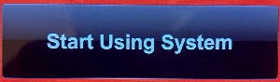
Start-up
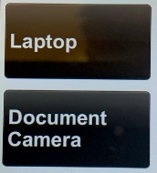
- Touch the Crestron touch panel to wake up, then click “Start Using System”
- Touch your desired source(s) and send by touching one or both displays icons.
Connecting a Laptop
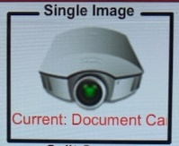
- Plug the proper video cable into your personal device using USB-C or HDMI (+ USB for laptop sound) cable (Cables may be retracted into cable cubby).
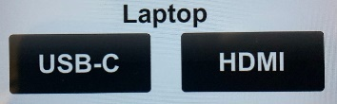
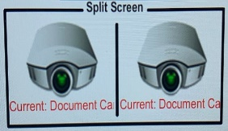
- Touch/tap your desired source and then touch the icon for the correct cable, then touch/tap “Single Image” or “Split Screen” to send your laptop’s display to desired projector.

- Make sure your cable is completely seated all the way in your laptop.
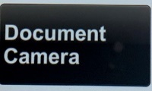
Document Camera
- Touch the Creston touch panel to turn it on.
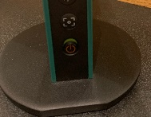
- Touch/tap the Document Camera option on the side of the touch panel and touch/tap the desired display: “Single Image” or “Split Screen”.
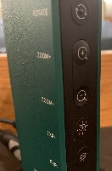
- Lift up the small red power switch near the document camera to turn it on and lift down to turn it off.
Zooming in and out
- Press the black buttons on the side of the document camera to zoom in and out.
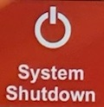
Shut-down
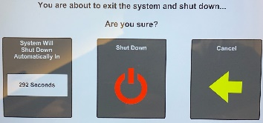
- Press the “System Shutdown” button located in the bottom left of the Crestron Touch panel. This will prompt a screen asking you if you are sure you want to shut down the system. Click “Shut Down” to shut down the Crestron and projector.

Audio

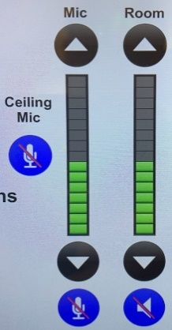
Mic Audio
Using the lapel microphone provided, turn on the unit and adjust the microphone volume using the up and down “Mic” arrows located on the right side of the Crestron. Extra batteries are provided.

Room Audio
To adjust the room speaker volume, use the up and down “Room” arrows located on the right side of the Crestron.

Raising and Lowering Front/Rear Blackboards and Projector Screen
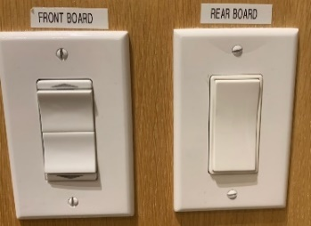
To raise the front and/or rear blackboard, use the switches on the wall labeled “FRONT BOARD” and “REAR BOARD”.

To raise and lower the projector screen, use the switch on the wall labeled “PROJECTOR SCREEN”.

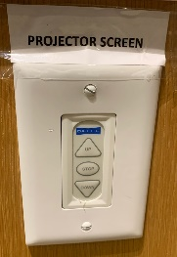

Zoom Room Instructions from Wacom Tablet
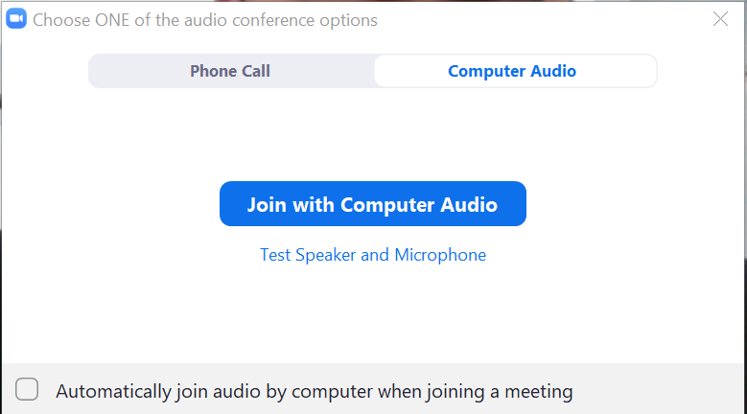
Joining the Room to your Zoom Meeting:
Create a Zoom meeting from your laptop. When prompted to “Join with Computer Audio”, click the “x” on the top right corner of the window. If you click “Join with Computer Audio”, there will be screeching audio feedback loop between your laptop and the room.

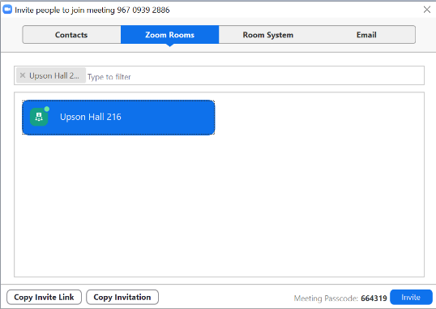
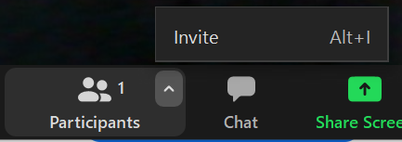
Along the Zoom options bar, to the right of “Participants”, click the up arrow and then click “Invite”. Click the “Zoom Rooms” tab, type your room in the search bar. Click the blue “Invite” button. The Wacom tablet will make a ringing noise and prompt a blue screen. Tap “Accept” on the Wacom tablet using the stylus provided.

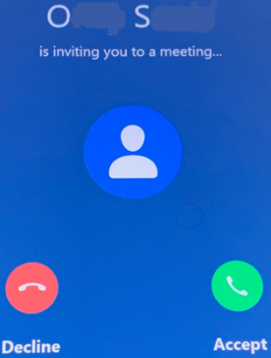

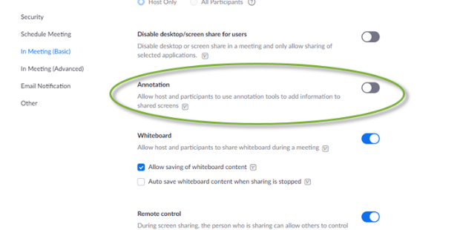
To Enable Annotation for Shared Content in your Zoom Meetings (From CIT):
Log in to your Cornell Zoom account, click settings. Under In Meeting (Basic), scroll down to the Annotation option. Click the gray slider button to the right of Annotation to enable it. The slider will turn blue when enabled.

When Annotation is enabled, two additional options appear. They determine who can annotate a shared screen and whether meeting participants can save annotated screens:
- Allow saving of shared screens with annotations: To allow meeting participants to save annotated shared screens, click this checkbox, then click Save when asked to confirm.
- Only the user who is sharing can annotate: Do not select this option, as it will prevent the Zoom Room (which is a participant) from being able to make annotations.

For more detailed information on Zoom annotation:
https://it.cornell.edu/zoom/zoom-rooms-annotate-shared-presentation

For more detailed information on Zoom Rooms: https://www.engineering.cornell.edu/MTEI/engineering-classroom-instructions/information-zoom-rooms

