Contact Information
For AV support:
In Case of an AV Emergency Call: 607-255-0778
Email: Eng. Classtech Support engrclasstech@cornell.edu
AV Support Availability: Monday thru Friday, 8:00am to 5:00pm

For Facilities support:
Submit a ticket: https://tdx.cornell.edu/TDClient/133/Portal/Home/
For Emergencies Dial: 911 CU Police: 607-255-1111

Room Equipment
2 Projectors 2 Projector Screens Speakers
Assisted Listening Wireless Microphones Wacom Tablet VGA & HDMI Connections Podium (Height Adjustable) Document Camera

Connecting Your Device
Start-up
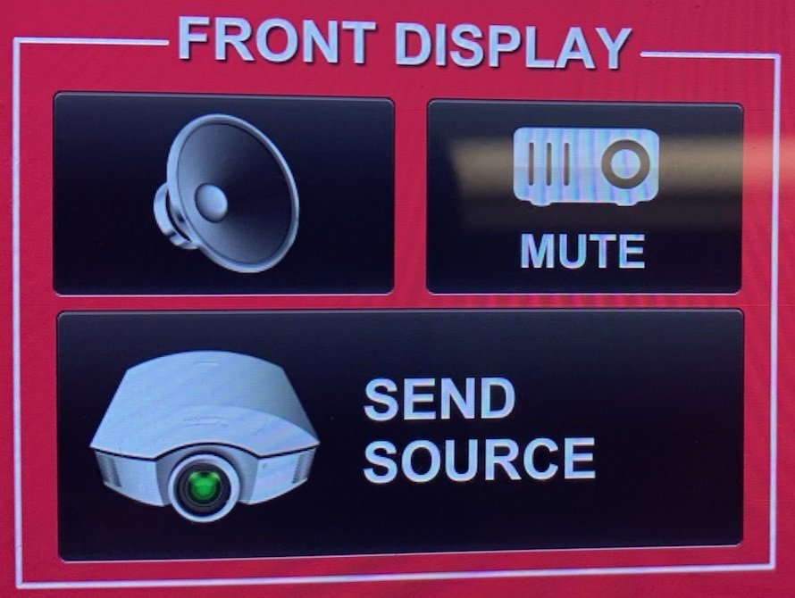
- Touch the Crestron touch panel to turn on.
- Select desired source(s) and send to one or both displays by touching “Send Source”.
Connecting a Laptop
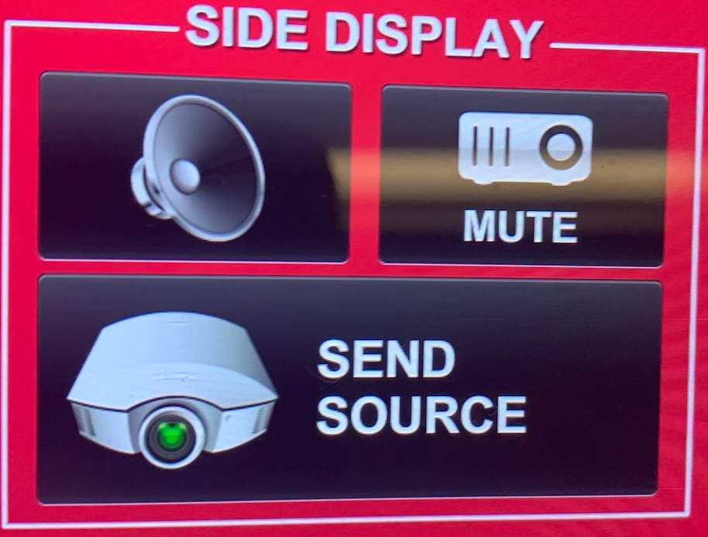
- Plug the proper video cable into your personal device (using HDMI or VGA cable).

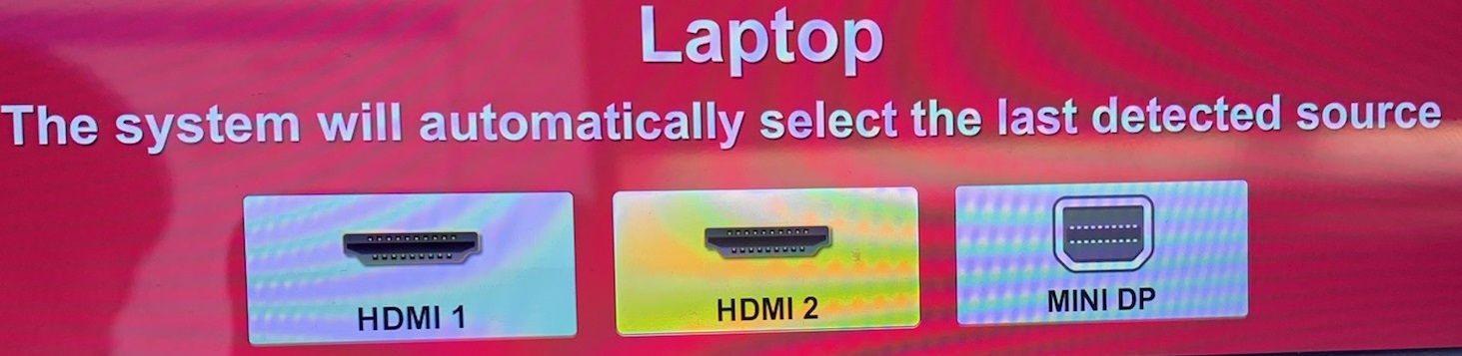
- Touch/tap your desired source and then touch the icon for the correct cable, then click “Send Source” to send your laptop’s display to desired projectors.

- Make sure your cable is completely seated all the way in your laptop.

Document Camera
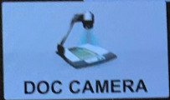
- Touch the Creston touch panel to turn it on.
- Touch/tap the DOC CAMERA option on the top bar of the touch panel and touch/tap the desired display’s “Send Source”.
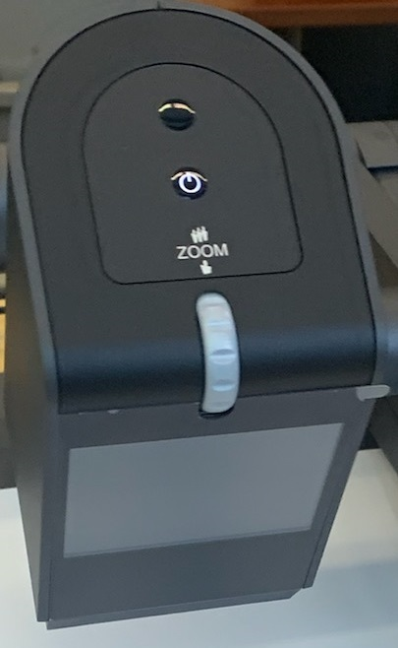
- Lift the arm of the document camera to turn it on and put the arm down to turn it off.
Zooming in and out
- Use the gray knob at the top of the document camera to zoom in and out.

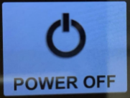
Shut-down
- Press the POWER OFF button located in the bottom left of the Crestron Touch panel. This will shut down the room.

Using the Wacom Tablet

To use the Wacom tablet in the room, please submit a ticket a week in advance to https://help.coecis.cornell.edu to schedule a training session.

If a problem occurs during a session, email https://help.coecis.cornell.edu and call 607-255-0778.

Audio

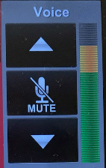
Voice Audio
Using the lapel microphone provided, turn on the unit and adjust the microphone volume using the up and down Voice arrows located on the right side of the Crestron. Extra batteries are provided.

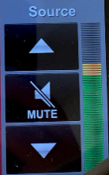
Source Audio
To adjust the room speaker volume from your laptop, use the up and down Source arrows located on the right side of the Crestron. (Make sure your laptop is unmuted)

Raising and Lowering Podium

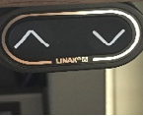
Located to your far left slightly underneath the front edge of the podium is a switch that allows you to raise or lower the podium. Use the up arrow to raise the podium. Use the down arrow to lower the podium.

Zoom Room Instructions from Wacom Tablet
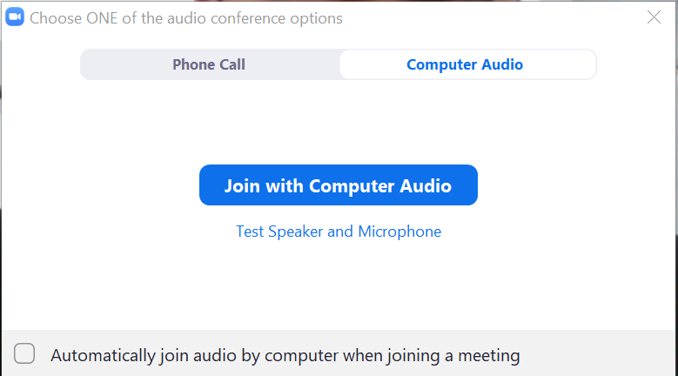
Joining the Room to your Zoom Meeting:
Create a Zoom meeting from your laptop. When prompted to “Join with Computer Audio”, click the “x” on the top right corner of the window. If you click “Join with Computer Audio”, there will be screeching audio feedback loop between your laptop and the room.

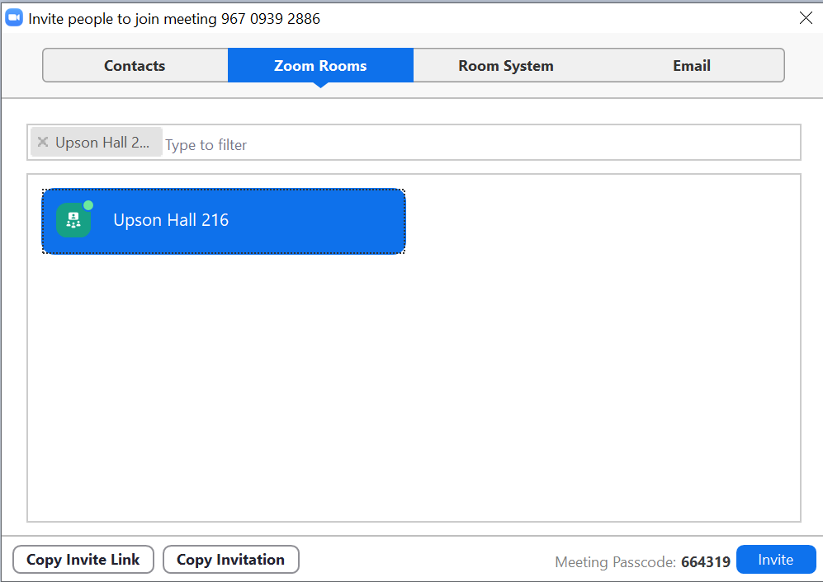
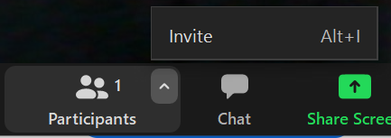
Along the Zoom options bar, to the right of “Participants”, click the up arrow and then click “Invite”. Click the “Zoom Rooms” tab, type your room in the search bar. Click the blue “Invite” button. The Wacom tablet will make a ringing noise and prompt a blue screen. Tap “Accept” on the Wacom tablet using the stylus provided.

To Enable Annotation for Shared Content in your Zoom Meetings (From CIT):
Log in to your Cornell Zoom account, click settings. Under In Meeting (Basic), scroll down to the Annotation option. Click the gray slider button to the right of Annotation to enable it. The slider will turn blue when enabled.

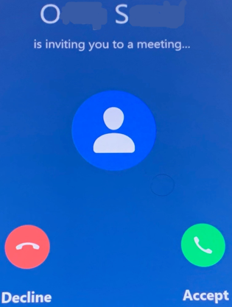
When Annotation is enabled, two additional options appear. They determine who can annotate a shared screen and whether meeting participants can save annotated screens:
- Allow saving of shared screens with annotations: To allow meeting participants to save annotated shared screens, click this checkbox, then click Save when asked to confirm.
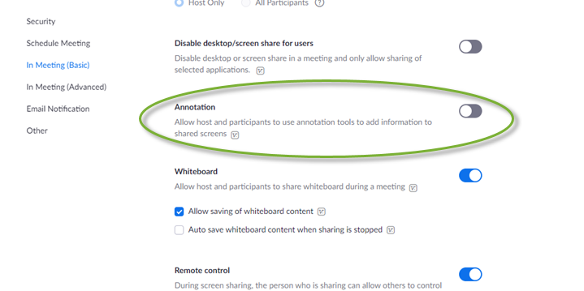
- Only the user who is sharing can annotate: Do not select this option, as it will prevent the Zoom Room (which is a participant) from being able to make annotations.

For more detailed information on Zoom annotation:
https://it.cornell.edu/zoom/zoom-rooms-annotate-shared-presentation
For more detailed information on Zoom Rooms: https://www.engineering.cornell.edu/MTEI/engineering-classroom-instructions/information-zoom-rooms

