Contact Information
For AV support:
In Case of an AV Emergency Call: 607-255-0778
Email: Eng. Classtech Support engrclasstech@cornell.edu
AV Support Availability: Monday thru Friday, 8:00am to 5:00pm

For Facilities support:
Submit a ticket: https://tdx.cornell.edu/TDClient/133/Portal/Home/
For Emergencies Dial: 911 CU Police: 607-255-1111

Room Equipment
2 Projectors 2 Projector Screens Speakers
Assisted Listening Wireless Microphones Document Camera HDMI & USB-C Connections Podium (Height Adjustable)

Connecting Your Device
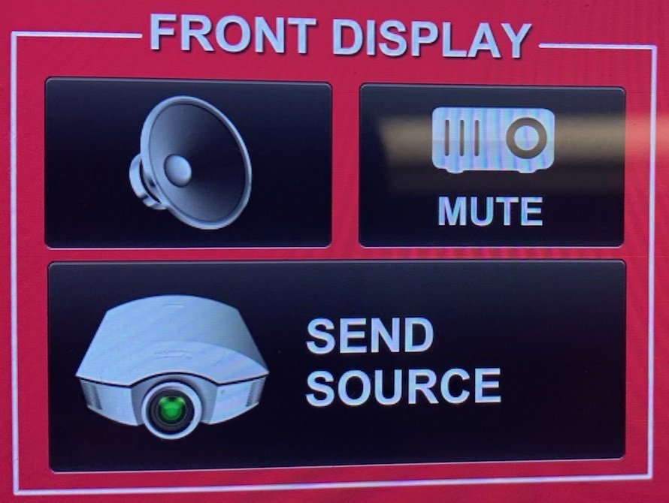
Start-up
- Touch the Room Control panel to turn on.
Connecting a Laptop
- Plug the proper video cable into your personal device (using HDMI or VGA cable).
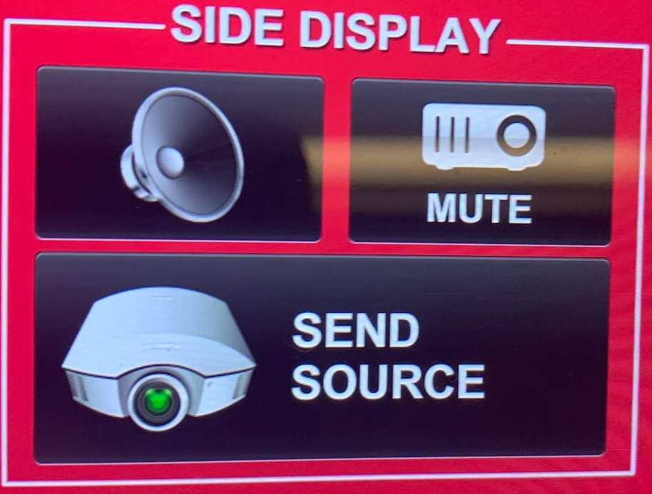
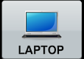
- Touch/tap your desired source and then touch the icon for the correct cable, then touch/tap “Send Source” to send your laptop’s display to desired projectors.

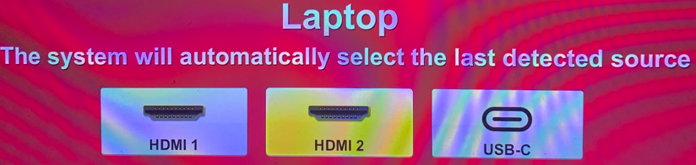
- Make sure your cable is completely seated all the way in your laptop.

Document Camera
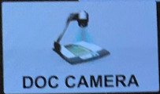
- Touch the Room Control panel to turn it on.
- Touch/tap the DOC CAMERA option on the top bar of the touch panel and touch/tap the desired display’s “Send Source”.
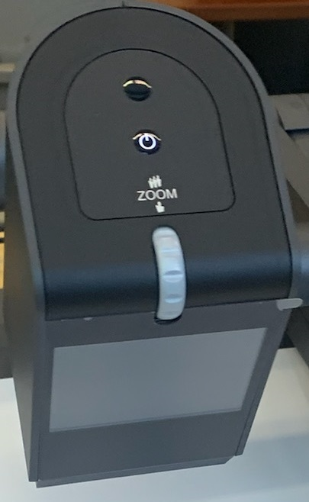
- Lift the arm of the document camera to turn it on and put the arm down to turn it off.
- Use the gray knob at the top of the document camera to zoom in and out.

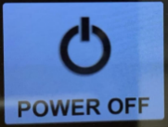
Shut-down
- Press the POWER OFF button located in the bottom left of the Crestron Touch panel. This will shut down the room.

Audio

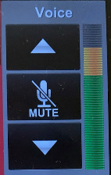
Voice Audio
Using the lapel microphone provided, turn on the unit and adjust the microphone volume using the up and down Voice arrows located on the right side of the Crestron. Place the unit in the charger when done.

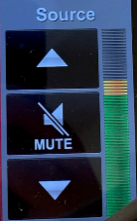
Source Audio
To adjust the room speaker volume from your laptop, use the up and down Source arrows located on the right side of the Crestron. (Make sure your laptop is unmuted)

Raising and Lowering Podium

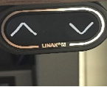
Located to your far left slightly underneath the front edge of the podium is a switch that allows you to raise or lower the podium. Use the up arrow to raise the podium. Use the down arrow to lower the podium.

Zoom Room Instructions

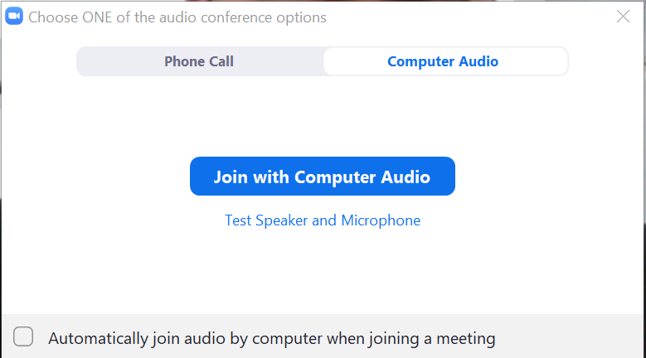
- Plug your laptop into the HDMI or USB-C cable at the lectern. On the Room Control panel, route laptop to projector(s) by touching/tapping the “Zoom Content” and/or “Zoom Primary” icon(s) and then touching/tapping “Send Source”.
- Start your Zoom meeting on your laptop.
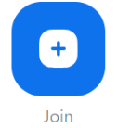
- When prompted to “Join with Computer Audio”, click the “x” on the top right corner of the window. If you click “Join with Computer Audio”, there will be screeching audio feedback loop between your laptop and the room.
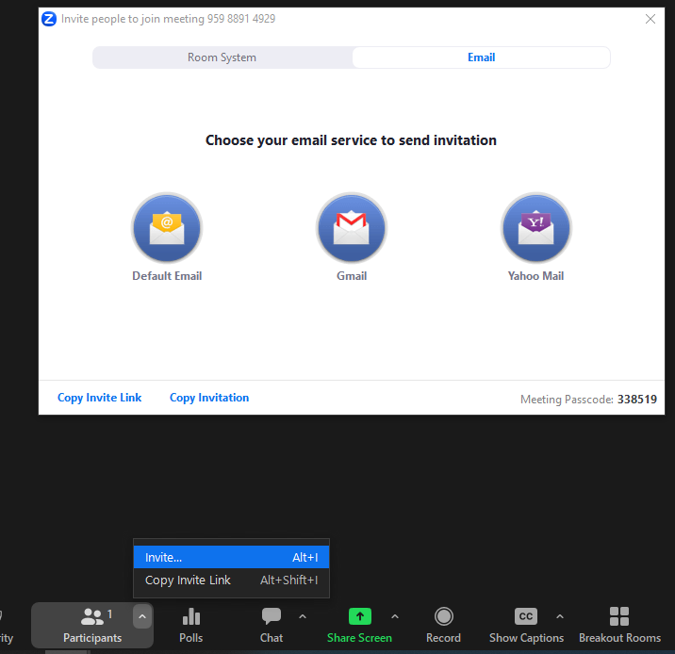
- Touch the Zoom Control panel to turn it on. Touch/Tap “Join”. When prompted, enter your Zoom meeting ID and passcode (To find this information, under “Participants”, click the top right arrow, and then click “Invite…”. In the pop up window, you’ll see the meeting ID on the top left corner and the meeting passcode on the bottom right corner.)

Once a screen share starts, “Zoom Primary” will stay gallery view and “Zoom Content” will be the screen share.
Zoom Primary Icon: Shows gallery view

Zoom Content Icon: Shows the active speaker until screen share is activated

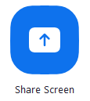
To wirelessly share your computer screen using the Zoom app and without starting a Zoom meeting:
- Route “Zoom Content” to at least one projector by touching/tapping the “Zoom Content” icon and then touching/tapping “Send Source”.
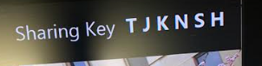
- From your laptop’s Zoom app home screen, click on the “Share Screen” icon.
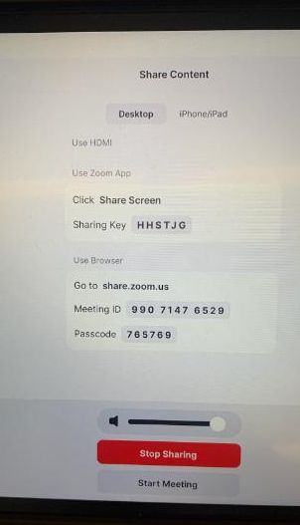
- Enter the Sharing Key when prompted. The Sharing Key will be located on the top right corner of the large flat monitor located to the right of the Room Control (if sent to “Front Display”) and the Zoom Control panel. They will also be on the Confidence Monitor(s) over the students (“Zoom Content” must be sent to at least one of the projectors to show the sharing key.). Another way of finding the Sharing Key is by tapping the Zoom Control panel, tapping “Share Content”. Be sure to tap “Stop Sharing” once connected.
To start your scheduled meeting from a Zoom Room:
- Find your scheduled meeting in your Zoom app.
- Click on “Join from a room”.
- Route “Zoom Content” to at least one projector by touching/tapping the “Zoom Content” icon and then touching/tapping “Send Source”.
- Enter the Sharing Key when prompted. The Sharing Key will be located on the top right corner of the large flat monitor located to the right of the Room Control (if sent to “Front Display”) and Zoom Control panels. They will also be on the Confidence Monitor(s) over the students (“Zoom Content” must be sent to at least one of the projectors to show the sharing key.). Another way of finding the Sharing Key is by tapping the Zoom Control panel, tapping “Share Content”. Be sure to tap “Stop Sharing” once connected.
- The meeting will launch on the Zoom Room and your laptop. Your laptop will not join the audio.

To pair the Zoom Room to a meeting already in-progress:
- On your laptop, in the upper right corner of the Zoom meeting window, click the button.
- Route “Zoom Content” to at least one projector by touching/tapping the “Zoom Content” icon and then touching/tapping “Send Source”.
- Enter the Sharing Key when prompted. The Sharing Key will be located on the top right corner of the large flat monitor located to the right of the Room Control (if sent to “Front Display”) and Zoom Control panels. They will also be on the Confidence Monitor(s) over the students (“Zoom Content” must be sent to at least one of the projectors to show the sharing key.). Another way of finding the Sharing Key is by tapping the Zoom Control panel, tapping “Share Content”. Be sure to tap “Stop Sharing” once connected.
- Hover over the button, you now have the option to switch the meeting to the Zoom Room.

Wireless Internet Connection

If you have a Cornell NetID or are visiting from an eduroam-participating institution, connect to Wi-Fi using eduroam.
- Select eduroam from the list of Wi-Fi networks on your device.
- Sign in using your NetID@cornell.edu (the full address is necessary) and NetID password. (eduroam-participating individuals should use credentials from their home institution.)
- Accept the network access certificate.

If you do not have a Cornell NetID, connect to Wi-Fi using Cornell-Visitor.
- Select Cornell-Visitor from the list of Wi-Fi networks on your device.
- A browser window will open automatically with the registration screen.
- Enter your name and email address, then check the box to accept the terms of use.
- Click Register.

Optional Equipment Available
For a list of available optional equipment, please visit:

https://www.engineering.cornell.edu/MTEI/mtei-equipment-check-out#no-back

