Contact Information
For AV support:
In Case of an AV Emergency Call: 607-255-0778
Email: Eng. Classtech Support engrclasstech@cornell.edu
AV Support Availability: Monday thru Friday, 8:00am to 5:00pm

For Facilities assistance:
Submit a ticket: https://tdx.cornell.edu/TDClient/133/Portal/Home/

For Emergencies Dial: 911 CU Police: 607-255-1111

Room Equipment
Projectors  Assisted Listing System | Projection Screens  Wireless Microphone | Speakers
For a list of available optional equipment please contact Kathy Dimiduk (klc78@cornell.edu)

Basic Projection

- Turn on your device and plug in HDMI, or the VGA (or your VGA converter) & Audio cable into your device or into your adaptor.
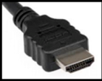  HDMI (digital) | 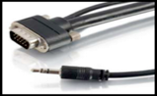 | VGA (analog)

- If necessary, wake up the Crestron by pressing the panel firmly with your finger.

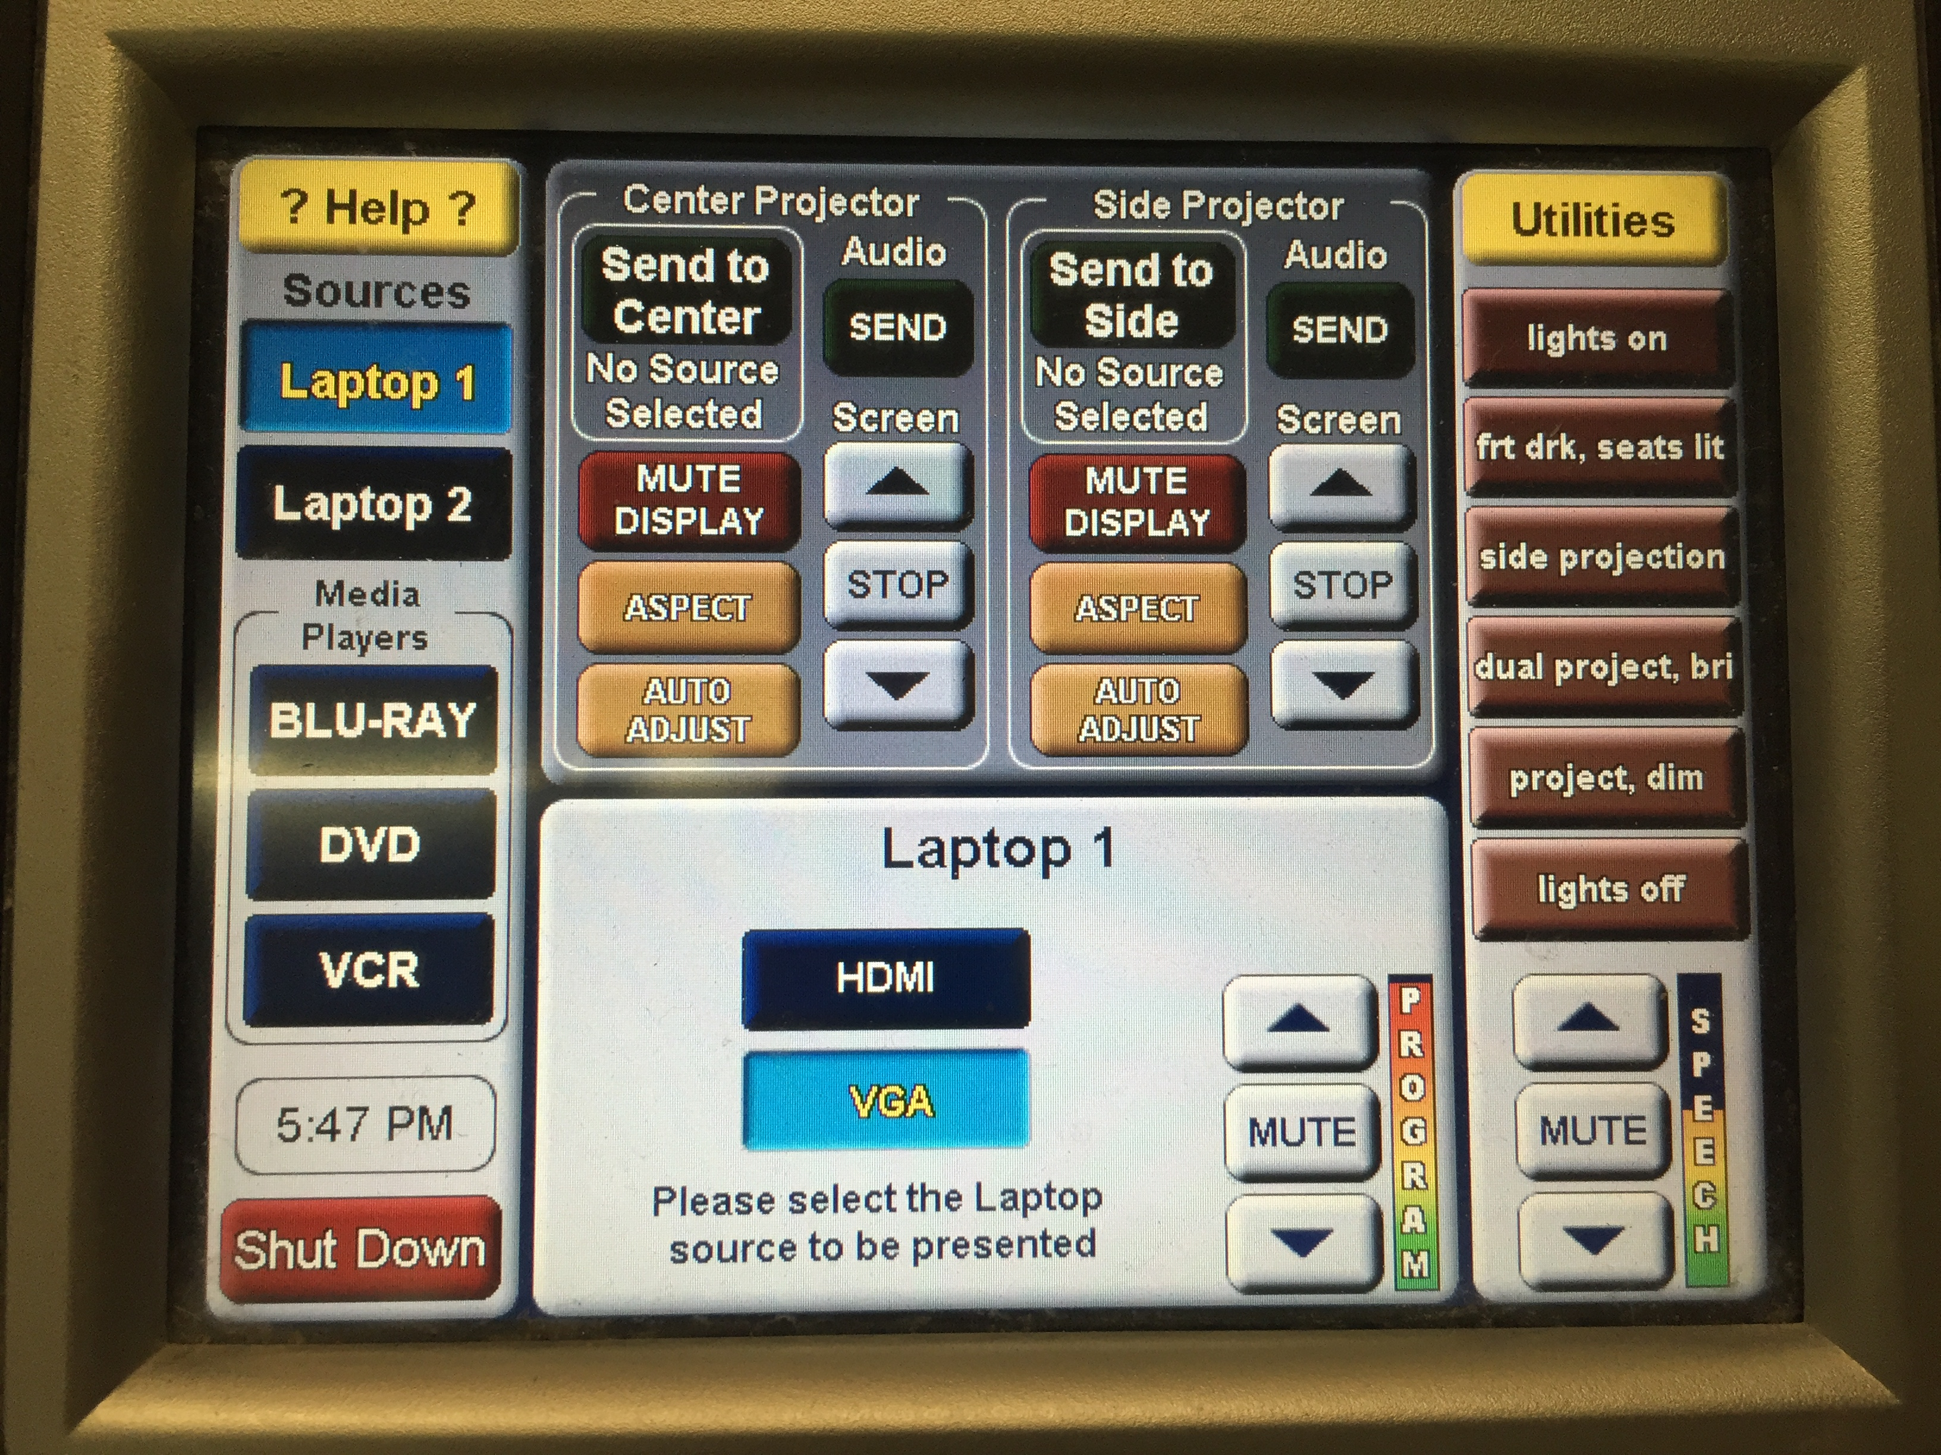
- Press Laptop 1 or Laptop 2 depending on which cable you plugged into your device.

- Press HDMI or VGA on the Crestron screen depending on the cable you are using.

- Press Send to Center or Send to Side on the Crestron screen for the room screen controls.

- The room screens can be lowered and raised by pressing the up or down arrows accordingly.
- To blank screen press Mute Display. To restore content, press Mute Display a second time.

- To shut down the system, press Shut Down on the lower left side of the Crestron screen.

Continued Basic Projection - Audio
Sound will be projected from the most recent source selected. As necessary,
re-select your source for desired sound. To adjust the room speaker volume, use the up and down arrow located on the right side of the Crestron.
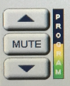

The Wireless Microphone and extra batteries can be found on or in the lectern (drawer). Adjust volume for the microphone by pressing the up or down arrows accordingly.

Wireless Internet Connection
If you have a Cornell NetID, use Eduroam for Wireless. When prompted, type in your NetID@cornell.edu. The full address is necessary.
Wireless Connection for Visitors:
- Click on Network icon.
- Select Cornell Visitor.
- Click Connect.
- Follow the instructions.

Troubleshooting
If no projection: Remove the cable from your device and reconnect the appropriate cable to check the connection to your device.

If content not fully projected on the screen:

Windows 7: | MAC:
- Press the “Windows” key + P | - Click on the Apple at the top of your computer screen.
- Select Duplicate. | - Click on Preferences.
 | - Click on Display.
 | - Click on Arrangement.
 | - Click on Mirror Display.

The resolution on your device may also need to be adjusted.

If no sound or sound is not from correct device: Sound is projected from the most recently selected source. If necessary, re-select your preferred sound source.
For questions about Wireless Internet Connection – http://www.it.cornell.edu/services/wifi/howto.cfm

Optional Equipment Available
For a list of available optional equipment, please visit:

https://www.engineering.cornell.edu/MTEI/mtei-equipment-check-out#no-back

