Contact Information
For AV support:
In Case of an AV Emergency Call: 607-255-0778
Email: Eng. Classtech Support engrclasstech@cornell.edu
AV Support Availability: Monday thru Friday, 8:00am to 5:30pm

For Facilities assistance:
Submit a ticket: https://tdx.cornell.edu/TDClient/133/Portal/Home/

For Emergencies Dial: 911 CU Police: 607-255-1111

Room Equipment
2 Projectors 2 Projector Screens VGA Connection
VGA/HDMI Adapter Assisted Listening Microphones
Wireless Presentations (Solstice Pod)

Connecting Your Device
Start-up
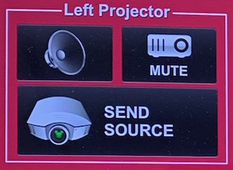
- Touch the Crestron touch panel to turn on.

- Select desired source(s) and send to one or both displays.

Connecting a Laptop
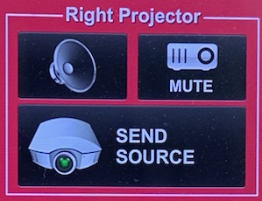
- Plug the proper video cable into your personal device (using HDMI or USB-C cable).

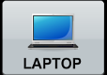
- Touch/tap your desired source and then touch the icon for the correct cable, then click “Send Source” to send your laptop’s display to desired projectors.
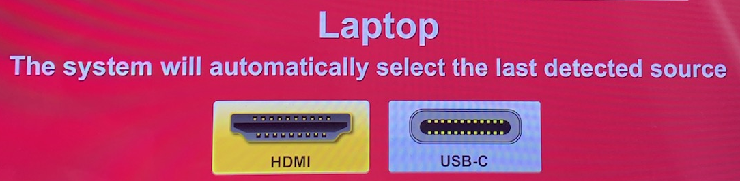
- Make sure your cable is completely seated all the way in your laptop.

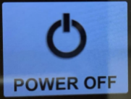
Shut-down
- Press the POWER OFF button located in the bottom left of the Crestron Touch panel. This will shut down the room.

Wireless Presentation (Solstice Pod)
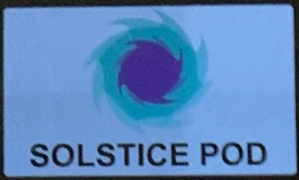
Press the SOLSTICE POD box near the top right corner of the Creston screen and send to the desired screen/display.
Follow the prompted instructions on the projector screen(s). Set up should take no longer than one minute.

If your content is not fully projected on the screen:
Windows: | Mac:
- Press the “Windows” Key + P.  - Choose Duplicate. | - Click on the Apple at the top of your computer screen.  - Click on Preferences.  - Click on Display.  - Click on Arrangements.  - Click on Mirror Display.

Audio

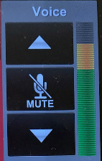
Voice Audio
Using the lapel microphone provided, turn on the unit and adjust the microphone volume using the up and down Voice arrows located on the right side of the Crestron.
Extra batteries are provided.

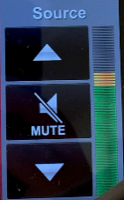
Source Audio
To adjust the room speaker volume, use the up and down Source arrows located on the right side of the Crestron.

Optional Equipment Available
For a list of available optional equipment, please visit:

https://www.engineering.cornell.edu/MTEI/mtei-equipment-check-out#no-back

