Phillips 101

Contact Information
For AV support:
In Case of an AV Emergency Call: 607-255-0778
Email: Eng. Classtech Support engrclasstech@cornell.edu
AV Support Availability: Monday thru Friday, 8:00am to 5:00pm

For Facilities support:
Patty Gonyea plg27@cornell.edu (607)255-8588

For Emergencies Dial: 911 CU Police: 607-255-1111

Room Equipment
Projector Wall Projector Screen Document Camera
Assisted Listening Lapel Microphones IClicker
Laptop Connection (HDMI, VGA, Mini DisplayPort) Confidence Monitor Wireless Presentation (Solstice Pod)

Start Up
- If the touch panel is dark, touch control panel.
- Select your source on the touch panel.
- For laptop, connect HDMI, VGA, Mini DisplayPort or Solstice Pod (Wireless Presentation).

Dual Display
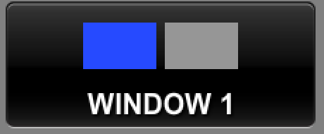
Click the “Video Windows” button
- Touch source for left screen, then touch Window 1.
- Touch source for right screen, then touch Window 2.
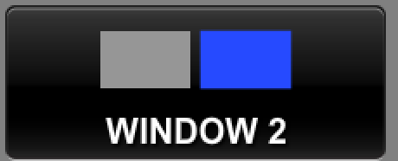
Changing dual display layout

Returns source to full screen. Click again returns dual image.

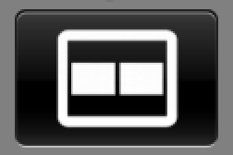
Displays the two sources side by side.

This button will swap the images to display in the opposite box.

Displays Windows 2 image inset in Windows 1 image. Pressing this button multiple times will move the small image to other corners on the screen.

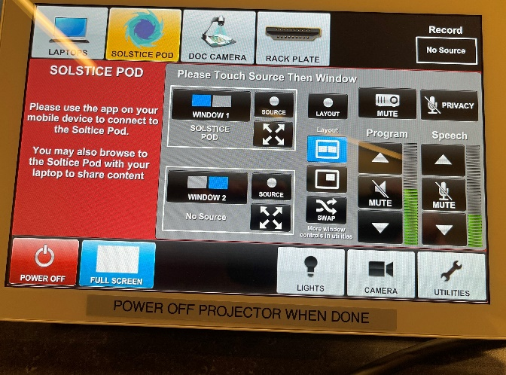
**Control panel recording buttons temporarily disabled due to COVID**

The privacy button will mute the lavalier mic and handheld mic from the recording. WARNING: The Chat 170 mic still records.

More Layout Options Available via Utilities

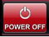
Powering Down Projector
Power off using the Crestron touch panel.

Audio

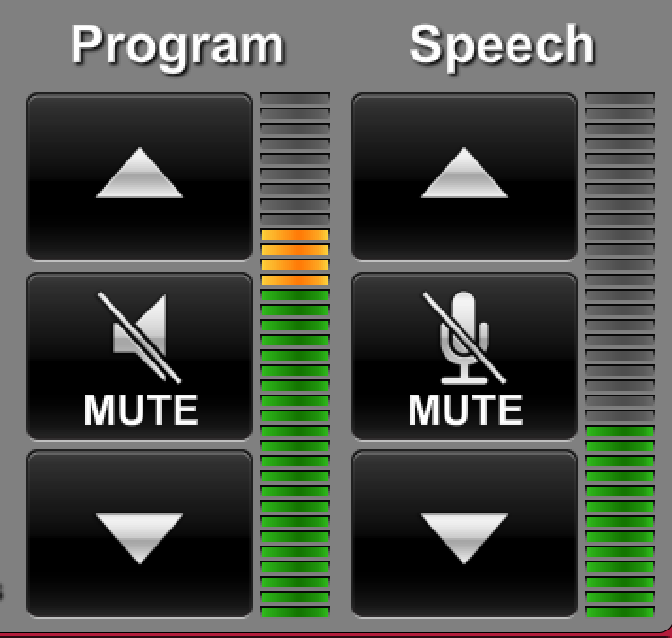
Program Audio
To adjust the room speaker volume, use the up and down Program arrows located on the right side of the Crestron.

Speech
Using the lapel microphone provided, turn on the unit and adjust the microphone volume using the up and down Speech arrows located on the right side of the Crestron.

