Phillips 219

Contact Information
For AV support:
In Case of an AV Emergency Call: 607-255-0778
Email: Eng. Classtech Support engrclasstech@cornell.edu
AV Support Availability: Monday thru Friday, 8:00am to 5:00pm
For Facilities support:
Submit a ticket: https://tdx.cornell.edu/TDClient/133/Portal/Home/

For Emergencies Dial: 911 CU Police: 607-255-1111

Room Equipment
Laptop connection (HDMI,VGA) Document Camera Room Speakers
Assisted Listening Room Microphones 2 Projector Screens
Wireless Presentation (Solstice Pod) Podium (Height Adjustable)

Connecting Your Device
Start-up
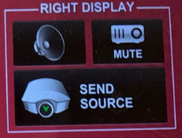
- Touch the Crestron touch panel to turn on.

- Select desired source(s) and send to one or both displays.

Connecting a Laptop
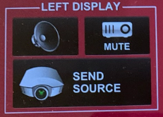
- Plug the proper video cable into your personal device (using HDMI or VGA cable).

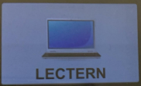
- Touch/tap your desired source and then touch the icon for the correct cable, then click “Send Source” to send your laptop’s display to desired projectors.
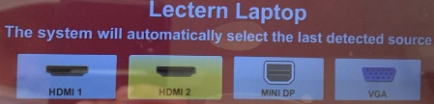
- Make sure your cable is completely seated all the way in your laptop.

Document Camera
- Touch the Creston touch panel to turn it on.
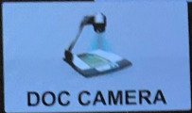
- Touch/tap the DOC CAMERA option on the top bar of the touch panel and touch/tap the desired display’s “Send Source”.

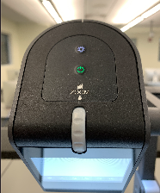
- Lift the arm of the document camera to turn it on and put the arm down to turn it off.

Zooming in and out
- Use the gray knob at the top of the document camera to zoom in and out.

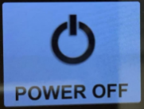
Shut-down
- Press the POWER OFF button located in the bottom left of the Crestron Touch panel. This will shut down the room.

Wireless Presentation (Solstice Pod)
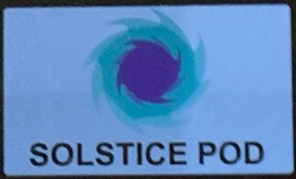
Press the SOLSTICE POD box near the top right corner of the Creston screen and send to the desired screen/display.
Follow the prompted instructions on the projector screen(s). Set up should take no longer than one minute.

If your content is not fully projected on the screen:
Windows: | Mac:
- Press the “Windows” Key + P.  - Choose Duplicate. | - Click on the Apple at the top of your computer screen.  - Click on Preferences.  - Click on Display.  - Click on Arrangements.  - Click on Mirror Display.

Audio

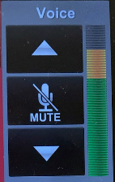
Voice Audio
Using the lapel microphone provided, turn on the unit and adjust the microphone volume using the up and down Voice arrows located on the right side of the Crestron.
Extra batteries are provided.

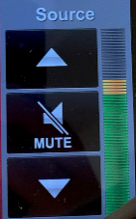
Source Audio
To adjust the room speaker volume, use the up and down Source arrows located on the right side of the Crestron.

Raising and Lowering Podium
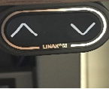
Located to your far left slightly underneath the front edge of the podium is a switch that allows you to raise or lower the podium. Use the up arrow to raise the podium. Use the down arrow to lower the podium.

Optional Equipment Available
For a list of available optional equipment, please visit:
https://www.engineering.cornell.edu/MTEI/mtei-equipment-check-out#no-back

