Contact Information
For AV support:
In Case of an AV Emergency Call: 607-255-0778
Email: Eng. Classtech Support engrclasstech@cornell.edu
AV Support Availability: Monday thru Friday, 8:00am to 5:30pm

For Facilities Assistance:
Submit a ticket: https://tdx.cornell.edu/TDClient/133/Portal/Home/

For Emergencies Dial: 911 CU Police: 607-255-1111

Room Equipment
2 Projectors 2 Projector Screens Speakers
VGA/HDMI Adapter Wireless Presentation (Air Media) Assisted Listening
VGA/HDMI/DP Connections Speakers 2 Remotes
Document Camera

Room Control (for both projectors)
- Connect your device
  - VGA, HDMI, or Display Port connection – Plug required cable directly into your laptop.
  - Other Connections – using different adapters
    - Connect the required cable directly into the necessary adapter, then into your laptop.
  - Air Media Wireless Connection
    - Do not connect your laptop. The Air Media will display on the screen.
    - Navigate to the IP address on the top of the screen and download for either Mac or Windows.
    - Launch Air Media. It will search for a local device.
If it doesn’t recognize a device, follow the steps below:
      - Enter the IP Address on the top bar (eg. 10.22.35.19).
      - Your username should be your NetID.
      - Enter the 4-digit code located on the top right of the Air Media screen.
      - Press Connect.
- Turn on the projector with the remote supplied (for both projectors).

Document Camera
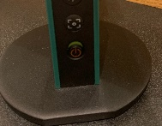
- Lift up the small red power switch near the document camera to turn it on and lift down to turn it off.
Zooming in and out
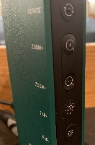
- Press the black buttons on the side of the document camera to zoom in and out.

If your content is not fully projected on the screen:
Windows: | Mac:
- Press the “Windows” Key + P.  - Choose Duplicate. | - Click on the Apple at the top of your computer screen.  - Click on Preferences.  - Click on Display.  - Click on Arrangements.  - Click on Mirror Display.

Raising and Lowering Podium
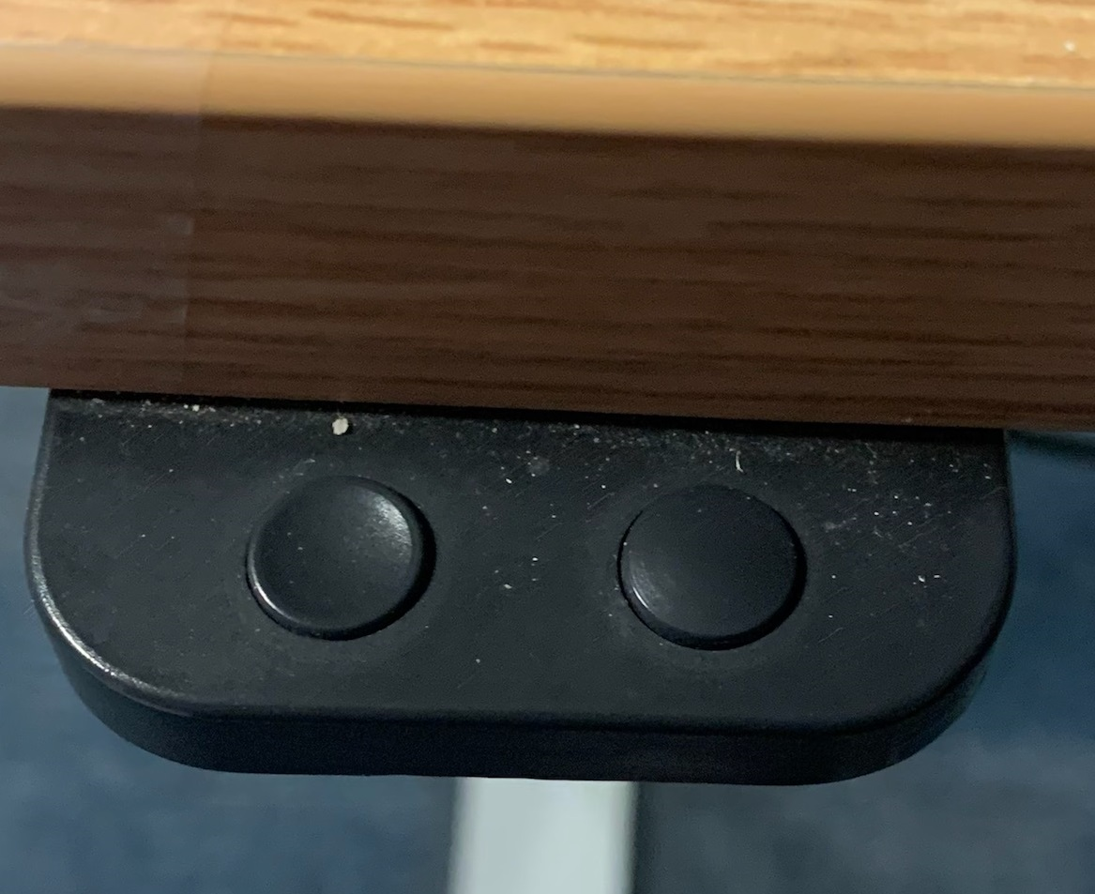
Located to your far left slightly underneath the front edge of the podium is a switch that allows you to raise or lower the podium. Press and hold the right button to raise the podium. Press and hold the left button to lower the podium.

Optional Equipment Available
For a list of available optional equipment, please visit:

https://www.engineering.cornell.edu/MTEI/mtei-equipment-check-out#no-back

