Contact Information
For AV support:
In Case of an AV Emergency Call: 607-255-0778
Email: Eng. Classtech Support engrclasstech@cornell.edu
AV Support Availability: Monday thru Friday, 8:00am to 5:00pm

For Facilities support:
Patty Gonyea plg27@cornell.edu 607-255-8588

For Emergencies Dial: 911 CU Police: 607-255-1111

Room Equipment
Wireless Connection (Solstice Pod) 2 HDMI Connections VGA Connection
Mini-display port Connection Document Camera Speakers Document Camera 2 Projector Screens 2 Projectors
Room Camera Panopto Recorder Microphone
Assisted Listening Adjustable height podium iClicker Base

Connecting your Device
- Connect your device:
  - VGA Connection – Plug the VGA cable into your computer. Connect the Audio cable to the headphone jack on your device (laptop).
  - HDMI Connection – Use HDMI 1 or HDMI2.
  - Mini-display port –Connect to your device.
  - Other Connections – using different adapters as needed
    - Connect an adapter directly to one of the above cables. Do not use a double adapter or the image may be compromised or not display at all.
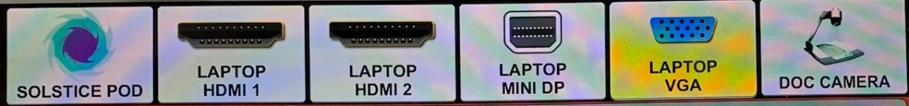
  - Wireless Connection – Choose the “SOLSTICE POD” as a source and follow the directions that appear on the screen.
- Turn on the projector with the Crestron touch panel
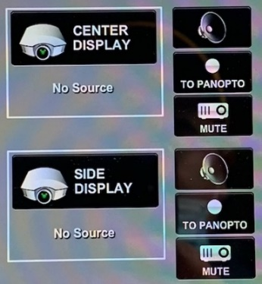
  - Tap the Crestron screen to wake it up
  - Touch your desired source.
  - Touch the projector icon for where you want to display that source.
The center screen is motorized and will come down when a source is applied to the center projector. The side screen needs to be pulled down manually.
- Mute: You can mute or blank either projector by pushing the mute button next to the projector icon.
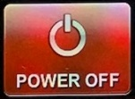
- Turn off the control panel when you are finished by tapping the “POWER OFF” button on the bottom left side of the Crestron.

If your content is not fully projected on the screen:
Windows: | Mac:
- Press the “Windows” Key + P.  - Choose Duplicate. | - Click on the Apple at the top of your computer screen.  - Click on Preferences.  - Click on Display.  - Click on Arrangements.  - Click on Mirror Display.

Audio

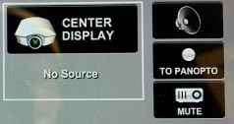
Program Volume:

Touch the speaker icon next to the display whose source should send the sound. Adjust the room speaker volume using the up and down arrows located under “Program” on the right side of the Crestron screen.
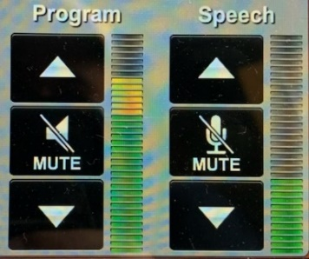
Microphone Volume:
Adjust the room microphone volume using the up and down arrows under “Speech” on the right side of the Crestron screen. Extra batteries for the microphone are on the podium or in the drawer in the AV rack under the podium.

Hearing assist headsets are in the side cabinet near the podium.

Lights
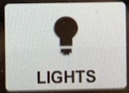
- Select “Lights” at the bottom of the control panel.
- Lighting presets can be selected using the buttons on the left (will be set up soon).
- Individual zones of lights can be made brighter or dimmer using the appropriate up and down arrows:
  - Zone 1: Fluorescent lights in the back of the room
  - Zone 2: Fluorescent lights over students in front of the room
  - Zone 3: Spot lights over the podium
  - Zone 4: Fluorescent lights on the blackboard
  - Zone 5: Spot lights along side of room.

Adjust the Podium
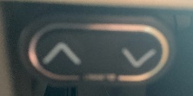
Podium: Use the buttons on the left side of the podium just under the top surface to adjust the height of the podium

Document Camera
Document camera:
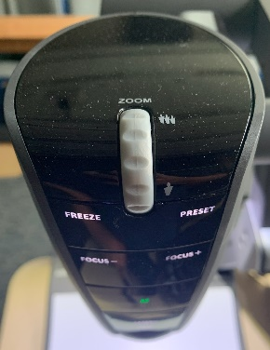
1. Press power on the document camera.
2. Pull the camera head and arm up to its full height.
3. Rotate the camera head so the lens points down.
4. Touch the document camera icon and then the appropriate projector icon to send the image to a screen.
5. Use the zoom wheel and focus buttons on the camera head to adjust the image.
6. Power off the Document Camera when done.
7. Lower the camera and arm by holding the top of the arm back with your left hand while gently pulling forward on the gray handhold at the center joint of the camera arm.

Recording a Lecture
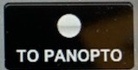
Select the “TO PANOPTO” button that corresponds to the display that you wish to record.
Submit a ticket to help.coecis.cornell.edu for assistance with setting up to record and to retrieve your recording.

Room Camera
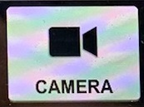
- Touch the camera button at the bottom of the control panel to go to the camera controls.
- Choose a preset that is closest to what you would like.
  - “Teacher” zooms in on the podium area.
  - “Wide” captures the whole front of the room.
  - Preset 3 will be set to capture the main screen or blackboards.
  - Preset 4 will be set to capture the side screen.
- Use the manual camera adjustments to fine tune where the camera is pointing. You can see what the camera is capturing on the confidence monitor in the back of the room.

Optional Equipment Available
For a list of available optional equipment, please visit:

https://www.engineering.cornell.edu/MTEI/mtei-equipment-check-out#no-back

