Contact Information
For AV support:
In Case of an AV Emergency Call: 607-255-0778
Email: Eng. Classtech Support engrclasstech@cornell.edu
AV Support Availability: Monday thru Friday, 8:00am to 5:00pm
For Facilities support:
Submit a ticket: https://tdx.cornell.edu/TDClient/133/Portal/Home/
For Emergencies Dial: 911 CU Police: 607-255-1111

Room Equipment
2 Projectors (Independent Images)  Assisted Listening System  2 side projectors | 2 Projection Screens  Document Camera  Wireless Presentation | Speakers  Portable Microphone
For a list of available optional equipment, please visit: https://www.engineering.cornell.edu/MTEI/mtei-equipment-check-out#no-back

Basic Lighting
Room lighting controls are located near the door.
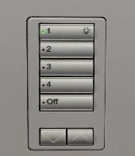
Pressing the top button will give you full lighting. As
you go down buttons the lighting will continue to dim.

Basic Projection

Turn on your device and connect to the system using one of the methods below. If you are using VGA, be sure to connect the Audio cable for sound. All sources besides VGA have autosensing, other sources will have the left front projector screen automatically feed into and turn on. To use VGA as a source, you will need to select the VGA source icon.
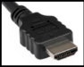  HDMI 1 (digital)  HDMI 2 (digital) | 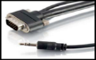  VGA  (analog) | 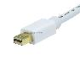  Mini Port Display | 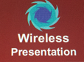  Wireless Presentation  (See Over)

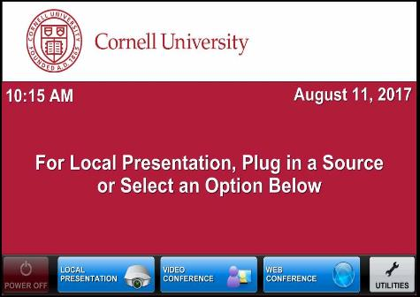
Note: If you connect your device through a source above while the Crestron is on the home page, the far projector screen will automatically lower and your presentation will automatically appear on both the far projector screen and distance learning screen located in the back of the room. If you do this you will not need to do Step 2 and Step 3.

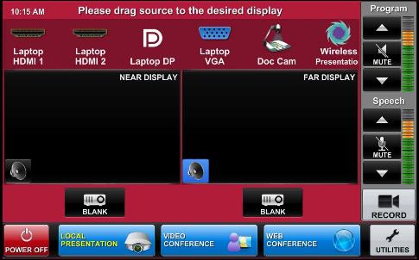
- Drag your source into each display area to have your presentation show on both projectors. Note that the projectors have independent images. You can select a different source for each projector by dragging it to the display area as show by the bottom right picture.
*(To view all sources that are available, simply swipe right and left at the top row of sources.)*

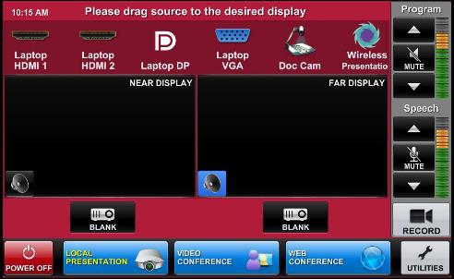
- Once finished dragging, the screen(s) will automatically lower and your presentation will appear on the projector screen(s). If they do not automatically lower, there is a manual control for the screens located near the door.

- To shut down the system, press Power Off
on the lower left side of the Crestron screen.
The document camera must be turned off manually.

Audio
Sound will be projected from the most recent source selected and the speaker by that source will turn blue. You cannot choose both audio sources at the same, you can only choose one source at a time.

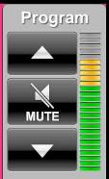
If necessary, select the sound from your other source by touching the
speaker icon by the source.

To adjust the room speaker volume, use the up and down Program arrows located on the right side of the Crestron.

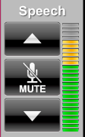
The microphone is in the top drawer of the cabinet attached to
the podium. Turn on the unit and adjust the microphone volume
using the up and down Speech arrows located on the right side of the Crestron. New batteries are located in the same top drawer if needed.

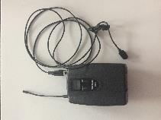
There is one listening assist student headset located
in the same top drawer. Note the difference between
Microphone
the microphone and the listening assist headset. The microphone is the third picture and the listening assist student headset is the fourth picture. There is an instructional sheet on how to
set up the listening assist student headset in the
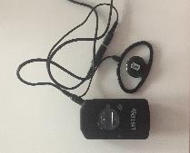
same top drawer.
Listening Assist Student Headset

Wireless Presentation
To activate the Wireless Presentation feature drag the Wireless Presentation source to either display area.

Follow the prompted instructions on the projector screen(s). Set up should take no longer than one minute.

Document Reader
To use document camera you need to
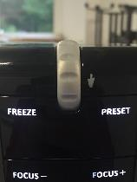
manually turn it on and drag the document
camera icon to the desired display source.

To turn the document reader on and off
press the power button. (Zoom In)

Note that the document camera wire is
long enough to move to the podium.

Wireless Internet Connection
If you have a Cornell NetID, use Eduroam for Wireless. When prompted, type in your NetID@cornell.edu. The full address is necessary.
Wireless Connection for Visitors:
- Click on Network icon.
- Select Cornell Visitor.
- Click Connect.
- Follow the instructions.

Raising and Lowering Podium
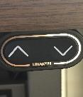
Located to your right slightly underneath the podium is a switch that allows you to raise or lower the podium. Use the up arrow to raise the podium. Use the down arrow to lower the podium.

Wall Whiteboards
Please note that the walls have whiteboards. The glass wall can also be used as a whiteboard. The screens for the side projectors can also be used as whiteboards but they do require eraser fluid to clean. Please have students clean at the end of class as they are much harder to clean if writing is left on them. DO NOT use permanent makers on them.

Troubleshooting
If no projection: Remove the cable from your device and reconnect the appropriate cable to check the connection to your device.

Recording
For information and training, please submit a request at engrclasstech@cornell.edu

Room Configuration joined with Upson 142 (Combine Rooms)
The request to combine must come from Upson 142.
The Crestron in Upson 146 will then ask for confirmation to combine the rooms.
Once combined, Upson 142 will be able to project content (2 independent streams such as camera on instructor and one screen of content) into Upson 146.
The audio source from teacher microphone should be picked up in Upson 142 and in Upson 146 and 152 if they are combined.
There are overhead mics in Upson 146 that will carry sound back into Upson 142.

For further information and training, please submit a request at engrclasstech@cornell.edu

Using the Side Screens (Collaboration Mode)
Turn on collaboration mode to turn on the side projectors.
Students can connect wirelessly to the side screens by following the directions on those screens.
For further information and training, please submit a request at engrclasstech@cornell.edu

Assistance on Room Features
Please submit a ticket a week in advance to https://help.coecis.cornell.edu to schedule a training session.

If you a problem occurs during a session, email https://help.coecis.cornell.edu and call
607-255-0778.

