Contact Information
For AV support:
In Case of an AV Emergency Call: 607-255-0778
Email: Eng. Classtech Support engrclasstech@cornell.edu
AV Support Availability: Monday thru Friday, 8:00am to 5:00pm

For Facilities support:
Submit a ticket: https://tdx.cornell.edu/TDClient/133/Portal/Home/
For Emergencies Dial: 911 CU Police: 607-255-1111

Room Equipment
2 Projectors (Independent Images)  Distance Learning Technology  Assisted Listening System | 2 Projection Screens  Document Camera  Wireless Presentation | Speakers  Portable Microphone
For a list of available optional equipment, please visit: https://www.engineering.cornell.edu/MTEI/mtei-equipment-check-out#no-back

Basic Lighting
Room lighting controls are located near each door.
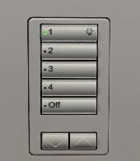
Pressing 1 will give you full lighting. As you go down
numbers the lighting will continue to dim (Pressing 3
will dim the lights more than pressing 2. Pressing 4
will dim lights more than pressing 3).

Basic Projection

- Turn on your device and connect to the system using one of the methods below. If you are using VGA, be sure to connect the Audio cable for sound.
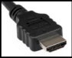  HDMI 1 (digital)  HDMI 2 (digital) | 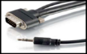  VGA  (analog) | 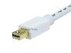  Mini Port Display | 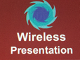  Wireless Presentation  (See Over)

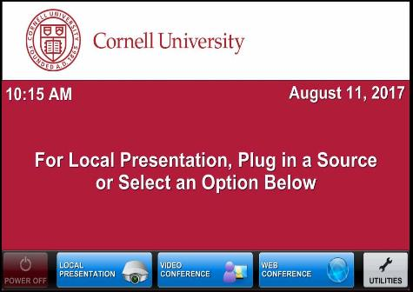
Note: If you connect your device through a source above while the Crestron is on the home page, the far projector screen will automatically lower and your presentation will automatically appear on both the far projector screen and distance learning screen located in the back of the room. If you do this you will not need to do Step 2 and Step 3.

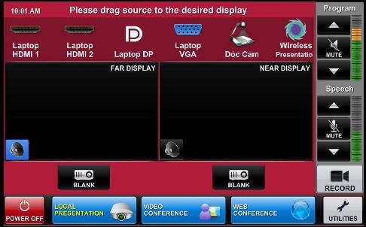
- Drag your source into each display area to have your presentation show on both projectors. Note that the projectors have independent images. You can select a different source for each projector by dragging it to the display area as show by the bottom right picture.
*(To view all sources that are available, simply swipe right and left at the top row of sources.)*

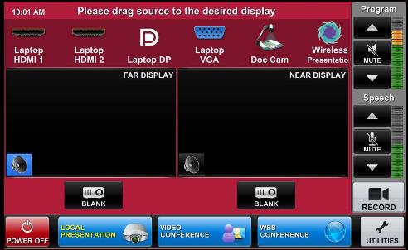
- Once finished dragging, the screen(s) will automatically lower and your presentation will appear on the projector screen(s). If they do not automatically lower, there is a manual control for the screens located near the door.

- To shut down the system, press Power Off on the lower left side of the Crestron screen. The document camera must be turned off manually.

Audio
Sound will be projected from the most recent source selected and the speaker by that source will turn blue.

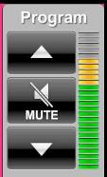
If necessary, select the sound from your other source by touching the
speaker icon by the source.

To adjust the room speaker volume, use the up and down Program arrows located on the right side of the Crestron.

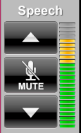
The microphone is in the top drawer of the cabinet attached to
the podium. Turn on the unit and adjust the microphone volume
using the up and down Speech arrows. New batteries are located in
the same top drawer if needed.

There is one listening assist student headset
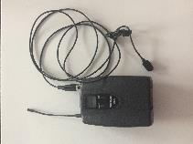
located in the same top drawer. Note the difference
Microphone
between the microphone and the listening assist
headset. There is an instructional sheet on how to set up the listening assist student headset in the same top drawer.

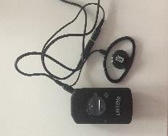
Listening Assist Student Headset

Wireless Presentation
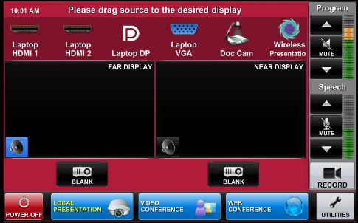
To activate the Wireless Presentation feature drag the Wireless Presentation source to either display area.

Follow the prompted instructions on the projector screen(s). Set up should take no longer than one minute.

Document Reader
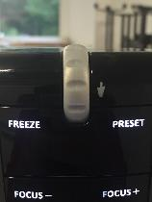
To turn the document reader on and off
press the power button.

Note that the document camera wire is (Zoom In)
long enough to move to the podium.

Wireless Internet Connection
If you have a Cornell NetID, use Eduroam for Wireless. When prompted, type in your NetID@cornell.edu. The full address is necessary.
Wireless Connection for Visitors:
- Click on Network icon.
- Select Cornell Visitor.
- Click Connect.
- Follow the instructions.

Raising and Lowering Podium
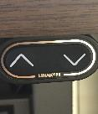
Located to your right slightly underneath the podium is a switch that allows you to raise or lower the podium. Use the up arrow to raise the podium. Use the down arrow to lower the podium.

Wall Whiteboards
Please note that the entire left and right walls are whiteboards. DO NOT use permanent makers on them.

Troubleshooting
If no projection: Remove the cable from your device and reconnect the appropriate cable to check the connection to your device.

Distance Learning
To use the distance learning feature of this classroom, please submit a ticket a week in advance to https://help.coecis.cornell.edu to schedule a training session.

If a problem occurs during a session, email https://help.coecis.cornell.edu and call 607-255-0778.

Zoom: Full-Featured Online Web and Video Conferencing Service

Note: To use Zoom make sure that you have downloaded the software and activated your Zoom account. Make sure you test the Zoom system in your classroom before using in class. Steps 1 through 7 show how to join a Zoom meeting. Skip to step 8 for setting up a Zoom meeting. This room is only capable of joining a Zoom meeting, it does not have the capability to create a Zoom meeting. Also note if you are teaching remotely using Zoom, you will need a person on campus, in this classroom, to open the Zoom meeting. If you have any questions regarding hosting a Zoom meeting, please visit: (https://support.zoom.us/hc/en-us/articles/201362613-How-Do-I-Host-A-Video-Meeting-)

Joining a Zoom Meeting

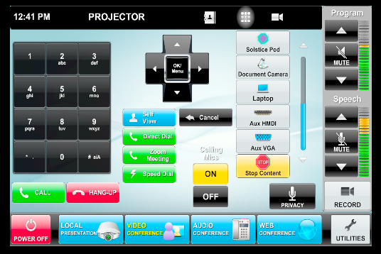
- Tap the touch panel to wake it up. From the home screen, select ‘Video Conference’.

- Joining; The easiest way to join a Zoom meeting is to select the green ‘Zoom Meeting’ button.

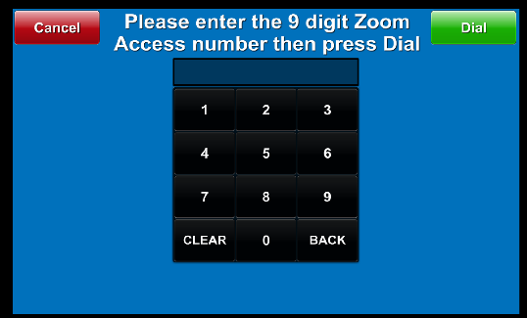
- Joining cont’d; This brings up the “Zoom Meeting Screen.” To join a Zoom meeting, just type in the Zoom meeting number and press the green “Dial” button in the upper right hand corner.

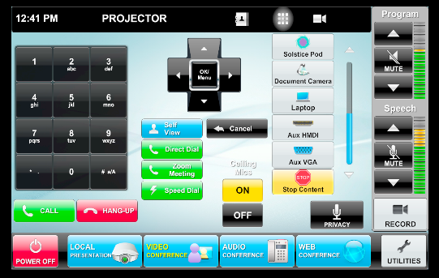
- Volume; The blue bar to the right of the gray buttons will determine the volume of the Zoom meeting. At the video conferencing controls, make sure that the “On” button under “Ceiling Mics” is yellow. If the local microphones aren’t working, try pressing the Privacy button once so it turns red, and then once more so it turns black again.

- Local Content; To share a laptop or other source from the room with the presenter, select it from the row of gray buttons on the right hand side of the screen.

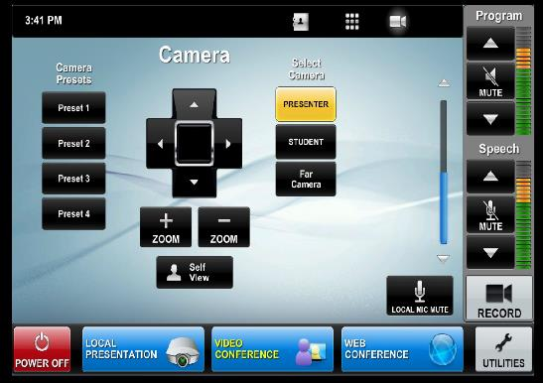
- Selecting Outgoing Camera; To change the outgoing camera view, touch the gray camera symbol on the right hand side of the black bar at the top of the screen.

- Camera Selection/Adjustments; You can select a camera (Sometimes called “Presenter” and “Student,” or “North” and “South”). You can use the arrow keys to move the camera the left and right or up and down, and there are “Zoom in” / “Zoom out” buttons under
the arrow controls. You can press
“Self View” to see or hide what the
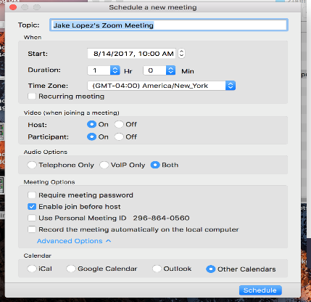
other participants of the Zoom meeting will see.

Scheduling a Zoom Meeting

- Scheduling Zoom Meeting; Make sure video for participant is on. When scheduling a Zoom Meeting for use with a room, you will want to click on ‘Advanced Options’ so you can see “Enable Join Before Host.” This will allow the room system to start the meeting if they join before anyone with a laptop does. Each user account can only have one active meeting at a time. (Zoom meeting must come from your
Device. You cannot set up a Zoom meeting
from the touch panel. )

Video Conferencing to Rooms with Video Conferencing Hardware

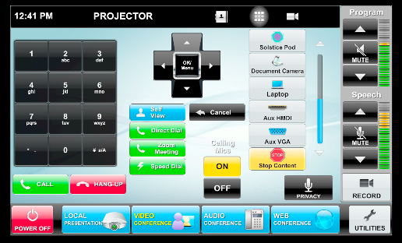
Note: Please make sure to test the room you’re trying to connect to before intended use.
- Tap the touch panel to wake it up.
From the home screen, select ‘Video Conference’.

- Contacts; From the Video Conferencing Screen, you can select the gray address book icon from the black bar at the top of the screen.

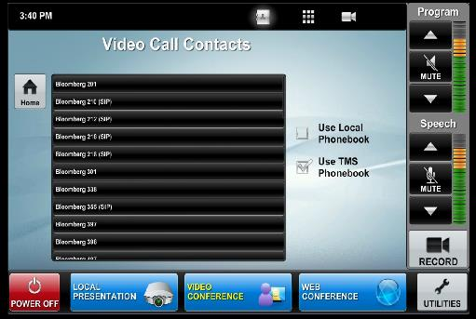
- Contacts Cont’d; This will bring up the directory of preconfigured locations. If you are calling a room in Ithaca, select “Use TMS Phonebook” to bring up a list of rooms. (Bloomberg Rooms only show in the TMS phone book)

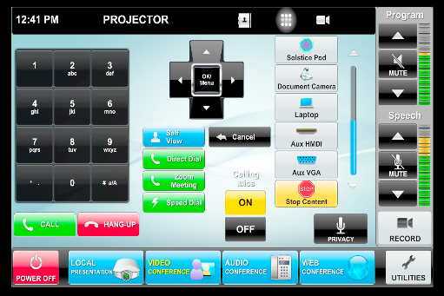
- Direct Call; You can also make a direct call by selecting the green “Direct Dial” button. *Note that if the room you’re trying to connect to is not in the directory, make sure that room has codec hardware otherwise you will not be able to connect to that room.

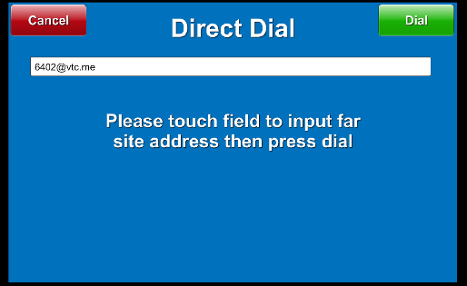
- Direct Call Cont’d; When direct dial is selected, you can enter a specific SIP address (ex: Phillips233@coecis.cornell.edu or Gates122@video.cornell.edu). You can also join a Zoom meeting by entering the Zoom meeting number followed by “@zoomcrc.com . When you touch the white bar, an onscreen keyboard should come up for you to enter. Once finished entering your desired SIP address, click the green “Dial” button located on the right top corner.

- Incoming Call; An incoming call
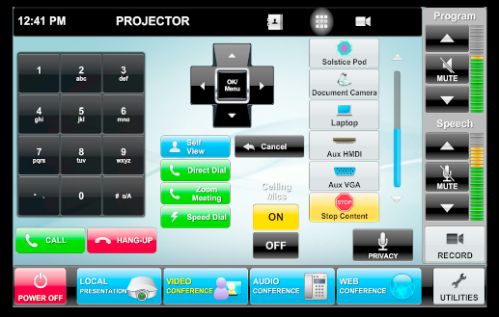
will cause a popup with a green
“Answer” button.

- Local Content; To share a screen or document camera, select it from the list of gray buttons on the right hand side of the screen. You will also want to make sure that the ceiling mics are set to “On”, and if there is no sound, try pressing the “Privacy” button once or twice to initialize the system.

