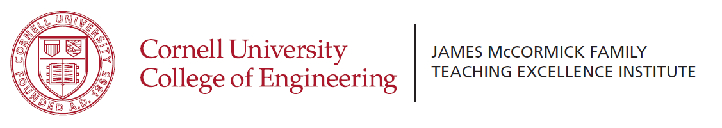
Internal Request for Proposals
Inspiring Course Redesign to Enhance Student Engagement and Learning

Introduction: Many engineering faculty recognize the potential value of redesigning their course to take advantage of new approaches and new technologies that have been shown to enhance student learning and engagement. However, for most faculty members already teaching a solid course, the time required to learn a new teaching style, introduce new technology, and redesign a course is not available. This inertia is especially apparent for sophomore and junior level required classes, which typically have large enrollments and are already intense classes with little room for experimentation. We conclude the most significant barrier to implementing these upgrades is faculty time.
The Inspiring Course Redesign to Enhance Student Engagement and Learning Initiative aims to provide faculty with the resources they need to redesign a course using modern pedagogy and digital resources. Proposals are requested to redesign a core sophomore or junior engineering course around a modern teaching pedagogy. The initiative will provide monetary support, additional TA support and MTEI support for the course redesign. It is anticipated that demonstrated successes in key courses will inspire other faculty to adopt similar modern teaching methods and pedagogies in their classes.
Potential Resources: Monetary support as justified by the redesign plan (not to exceed $45,000)
Faculty and Department Support:
- Funding to the department for teaching relief to gain focused time for course redesign
(can be split between co-teachers)
- Summer support for faculty
- Faculty attendance at a conference or workshop on teaching (for example, ASEE’s NETI workshop)
- Creating digital content to support flipping a class
- Purchasing equipment or software to support effective use of teaching technology
- Develop/adapt simulations for lectures or student assignments
- Lecture demonstration development
- Faculty attendance at advanced teaching workshops or conferences to share course redesign
Student Support
- Support for an additional r undergrad TA or partial grad TA for course development, gathering student input and assessment (TAship can be during the development semester or the first implementation semester; participating TAs should be selected for their interest in teaching and potential to pursue an academic career)
- Summer support for TA
MTEI assistance – no cost to project budget
- Discussions on pedagogy, implementation strategies, observations, assessment
- In collaboration with Academic Technologies, provide technical support for incorporating digital media and other innovative teaching technologies
- Commitment to pre-book, if needed, an appropriate active learning or technology enabled classroom (within constraints of existing classrooms)
- Assistance with assessment planning and implementation of surveys, observations
- Collaboration with professor and grad student TA to publish or present on the course

Target Courses: Target courses should be chosen so that the improved course will have a significant impact on student learning for nearly all students in an engineering major.
Target course requirements:
- core engineering courses with large impact at the sophomore/junior level will be given priority
- taught by a faculty member with strong teaching evaluations, who is ready to implement major changes in the course pedagogy, incorporate effective digital resources, and adapt the course structure to support enhanced learning
- commitment to piloting, implementing, assessing, and revising of new material and methods, typically across at least two instances of teaching the course
- identification of a realistic plan to sustain successful modifications to the course in the future

Preference will be given to:
- courses that make effective use of technology such as video segments for a flipped class, simulations that can be explored in homework, clickers for efficiently gathering responses from all students or groups, e-portfolios or lab archives, piazza for shared questions, and/or a technological approach to enable group work between local and distance students (as relevant)
- faculty who have shown interest in course innovation and significant course revisions
- clear plans for restructuring how time spent learning occurs both inside and outside of class
- creation of a sustainable, exemplary, modern course
- priority will be given to courses offered Fall 2017
Faculty Requirements:
- Tenure-track faculty, Lecturers and Senior Lecturers are eligible to submit proposals
- Effective teachers who have recently taught or co-taught the target course
- Commitment to making major changes to the course, including adopting a new pedagogy and making effective use of technology. It is the intent of this RFP to encourage faculty to consider the best pedagogical approach for the course in question
- Department buy-in for sustaining the newly developed course
- Commitment to sharing information on redesigned course both within and external to Cornell
- Willingness to mentor other faculty interested in making similar changes in other courses
Application Process:
A 2 page letter of intent (LOI) is due by May 15. The letter of intent should include:
- Information on the target course
- Information on the proposed teaching innovation(s) and changes to the course
- Proposed approach to sustaining the course innovations
- Proposed use of budget
- Endorsement by the department chair or director. No more than 2 LOI per department.
Full proposal due June 1st. The full proposal expands on the LOI and is limited to 4 pages plus a budget page and an endorsement page.

Workshop: A lunch workshop will be held on April 24 in McManus lounge. Faculty who have redesigned courses in the past few years will share their experiences.
Questions: Questions should be directed to Kathryn Dimiduk, klc78@cornell.edu, Director of the James McCormick Family Teaching Excellence Institute in the College of Engineering.

